US car accidents data was collected from various APIs that provide streaming traffic incident data from various entities such as the US and state departments of transportation, law enforcement agencies, traffic cameras, and traffic sensors within the road networks. Currently, there are about 1.5 million accident records in this dataset.

**EXECUTIVE SUMMARY**

**Major Findings:**

***Reason for concern:*** The global [report](https://www.who.int/violence_injury_prevention/road_safety_status/2018/en/) from the World Health Organization — which reviewed laws and crashes in 175 nations — explains that U.S.’s traffic fatality rate is 12.4 deaths per 100,000 — or about 50 percent higher than similar nations in Western Europe, plus Canada, Australia and Japan. About 1.3 million people are being killed globally by traffic crashes every year, a huge proportion of them pedestrians. Traffic deaths are now the leading cause of death globally for those between the ages of 5 and 29. This report will analyze US accidents on road and the factors affecting them.

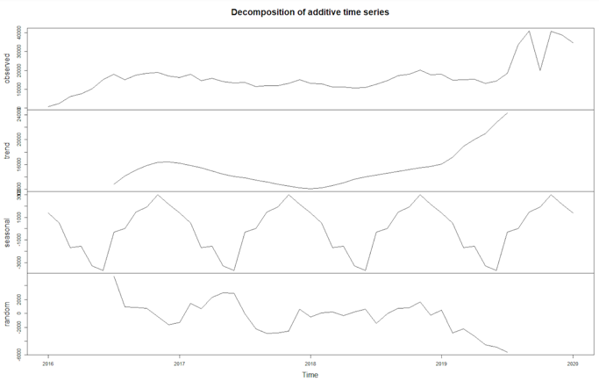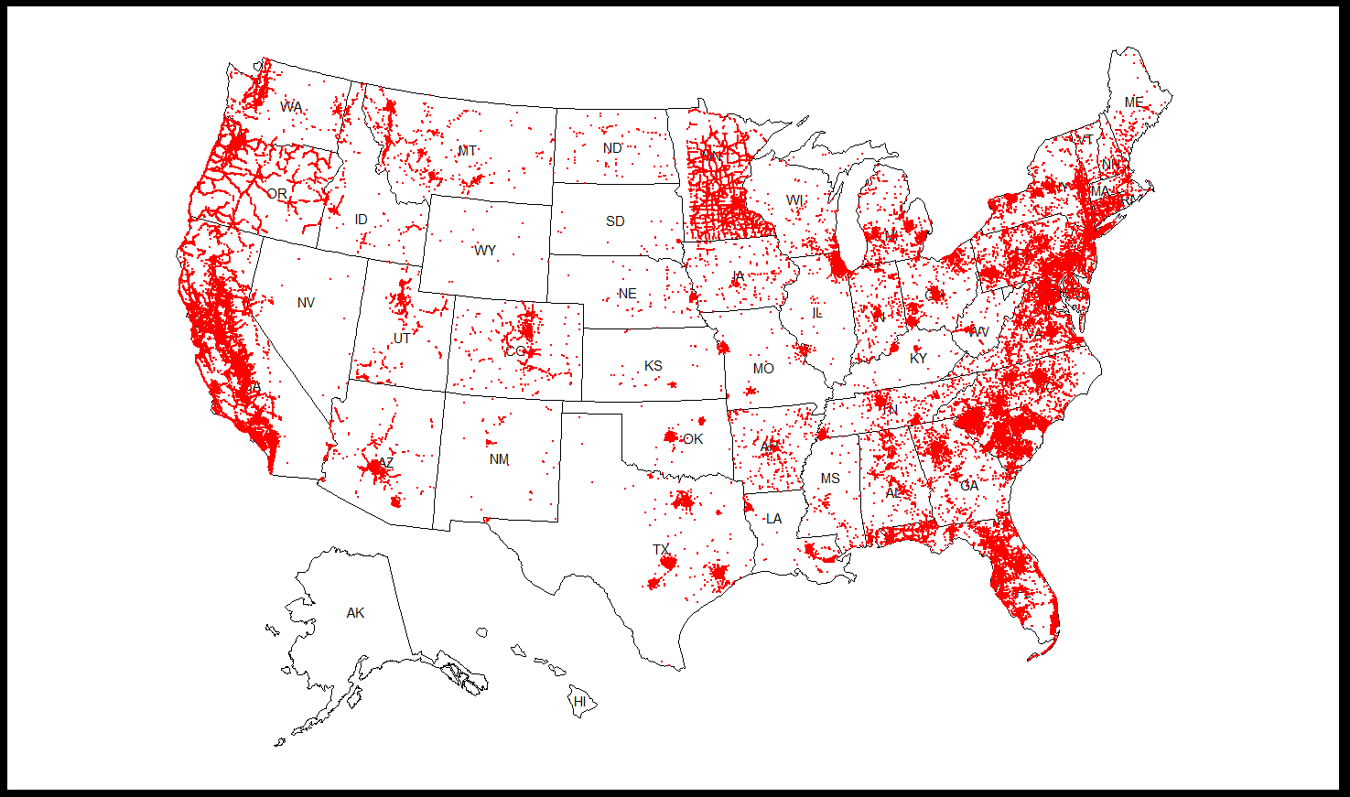The chart shows the accidents occurred through these across USA and the intensity can be clearly identified with the intensity of red points on the map. The chart was plotted using the dataset used for the project. The severity of the accidents was predicted using the regression models to provide appropriate recommendations.

***Further Understanding:*** The dataset included 47 variables that were all utilized to understand the impact on severity of the accidents and forecast the trends for number of accidents accordingly.

***Initial data concerns:*** Within each year, there is a significant change in trends for random, observed and trend. These are accounted for various models. The change in trend shows the outliers in the years 2019 to 2020 which could be because of the snowstorms, tornados, or other weather conditions. The hit of pandemic could also be part of the reason for outliers in data.

***Final outcomes and analyses:*** The final output of this analysis is a forecast for number of accidents and severity for the years 2019 and 2020, applying assumptions of data from 2016 to 2018 several models were used to capture the aspects that affected the accidents in all states, counties, and streets. The model with least errors was selected to simulate the outcomes for the years forecasted.

Severity=1.583568-0.0328198*Temperature(F)-0.1880180*Civil_Twilight-0.2986898*Nautical_Twilight+0.9932627*Astronomical_twilight+0.0186887*Humidity+0.1526831*Pressure+0.0062393*wind_speed(mph)-0.4012353*Precipitation(in)

***State with greatest number of accidents:***

* The data analysis of US data accidents shows that the greatest number of accidents occurred in the state of California which has a population of 39.1 million.The accidents that were recorded are 77247 from the year 2016 to the year 2020.
* The second greatest accidents were recorded in Florida for the same time with number 53173.

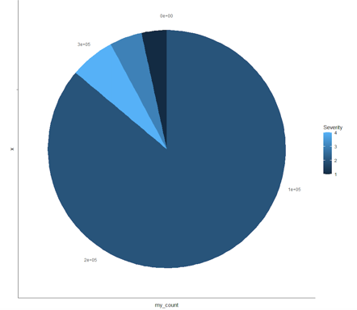***Severity of the accidents:***

* The frequency of severity of all the accidents occurred recorded level 2 which is not too severe and damaging, the total number of level 2 accidents are 288919.
* The second highest severity of accidents recorded is of level 4 with the record of 20399. The severity level 1 is recorded the least of all the levels with 11483 records of accidents.

***County with greatest number of accidents:***

* The data analysis also reports that the county with highest number of accidents recorded is Miami-Dade in Florida. It had 973 accidents for the mentioned period.
* The second highest accidents of about 431 were recorded in Kendal Lakes, Florida.

***Street with greatest number of accidents:***

* The street with most number of accidents Highway 101(California, Oregon,Washington), reporting 1190 accidents from 2016 to 2020.
* The second highest accidents in streets were recorded in South Dixie highway, reporting 1147 accidents.

***Recommendations:***

* The response teams and hospitals must be given special provisions in the hours in which most accidents are occurred.
* Warning signs about speed limits are to be put in the accident prone streets
* The state with highest accidents must be provided with better resources and budget plans to avoid accidents and rescue the victims.
* Warnings are to be put depending on the weather conditions which cause accidents.
* A mandate of vehicles to have first aid kit should be passed.
* Online surveillance for prompt response from emergency services should be implemented.
* To have enough response teams to rescue in accident prone locations

**APPENDIX**

library(psych)

install.packages("ISLR")

library(ISLR)

library("dlookr")

library(MASS)

library(dplyr)

library(car)

library(lmtest)

library(tidyverse)

library(broom)

library(ggplot2)

library(tidyverse)

library(caret)

library(lubridate)

library(readr)

library(ggpubr)

library(zoo)

library(tseries)

library(MLmetrics)

library(forecast)

library(usmap)

library(sp)

library(rgdal)

library(raster)

library(gstat)

library(gridExtra)

**EXPLORATORY DATA ANALYSIS:**

*Library ISLR displays the datatype and content of the variables.

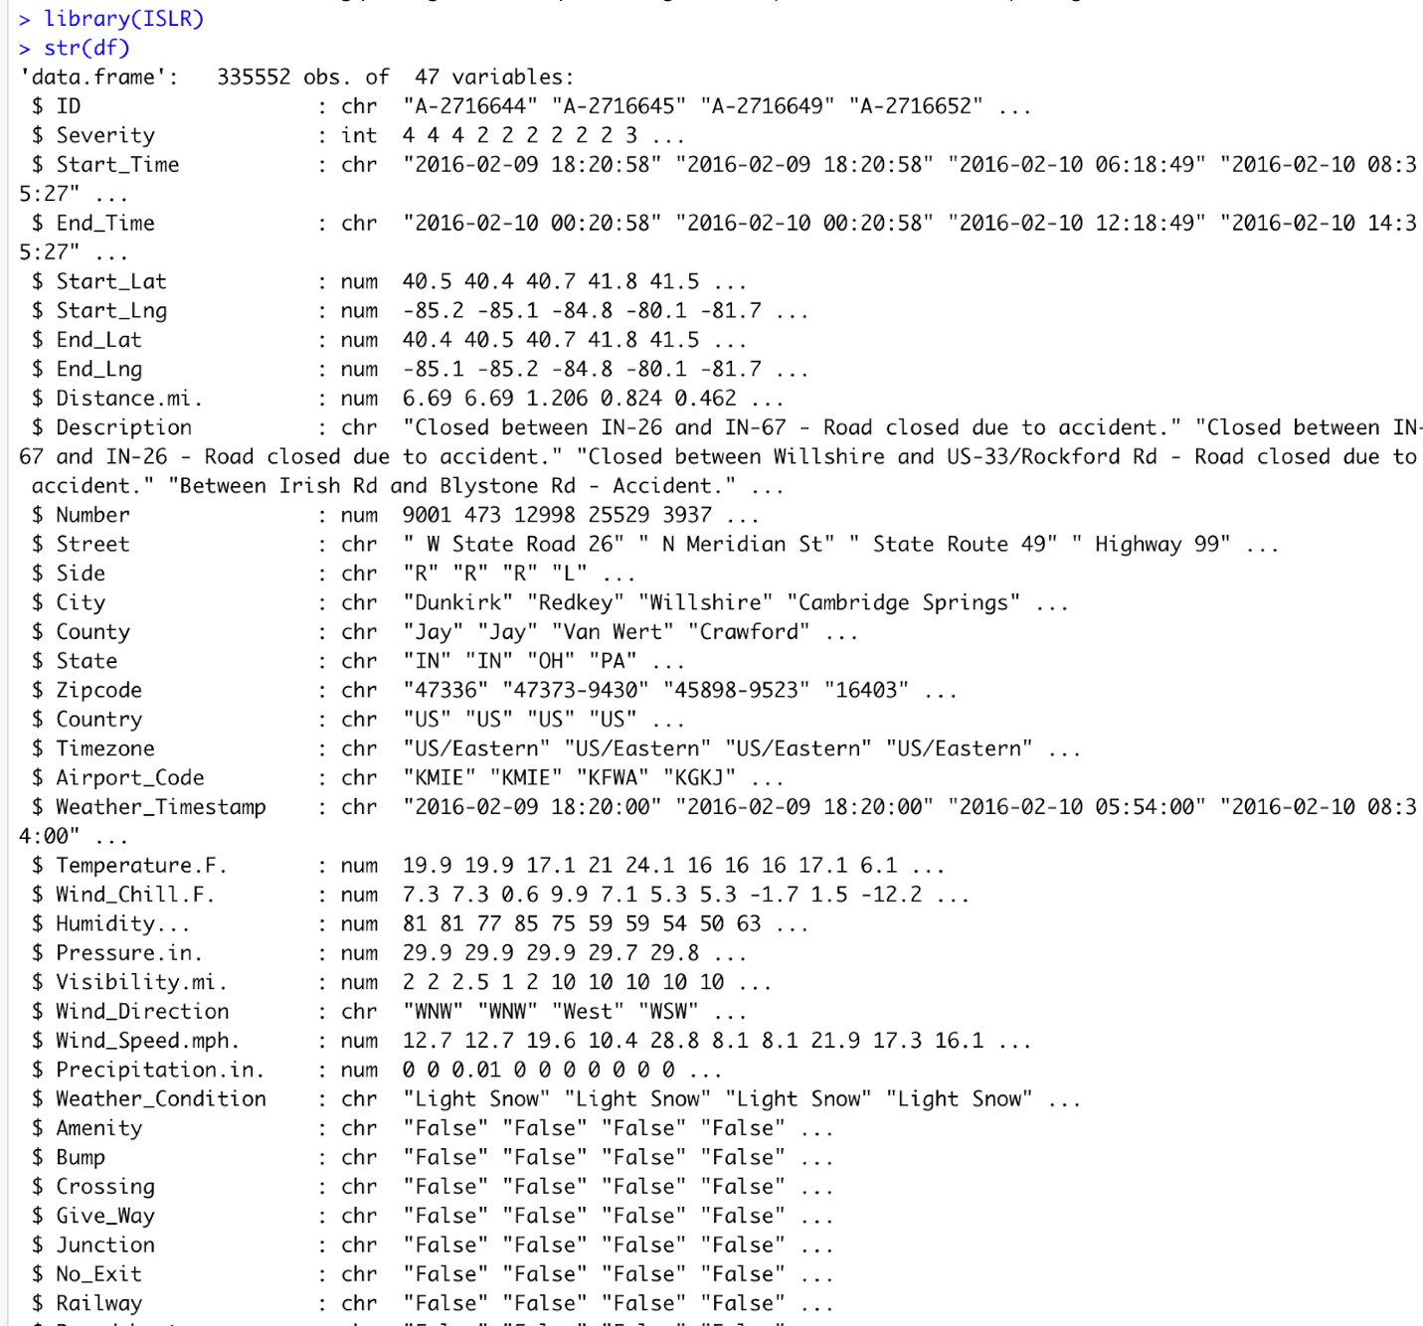

*Summary of the dataset shows all the required information for further analysis of the data.

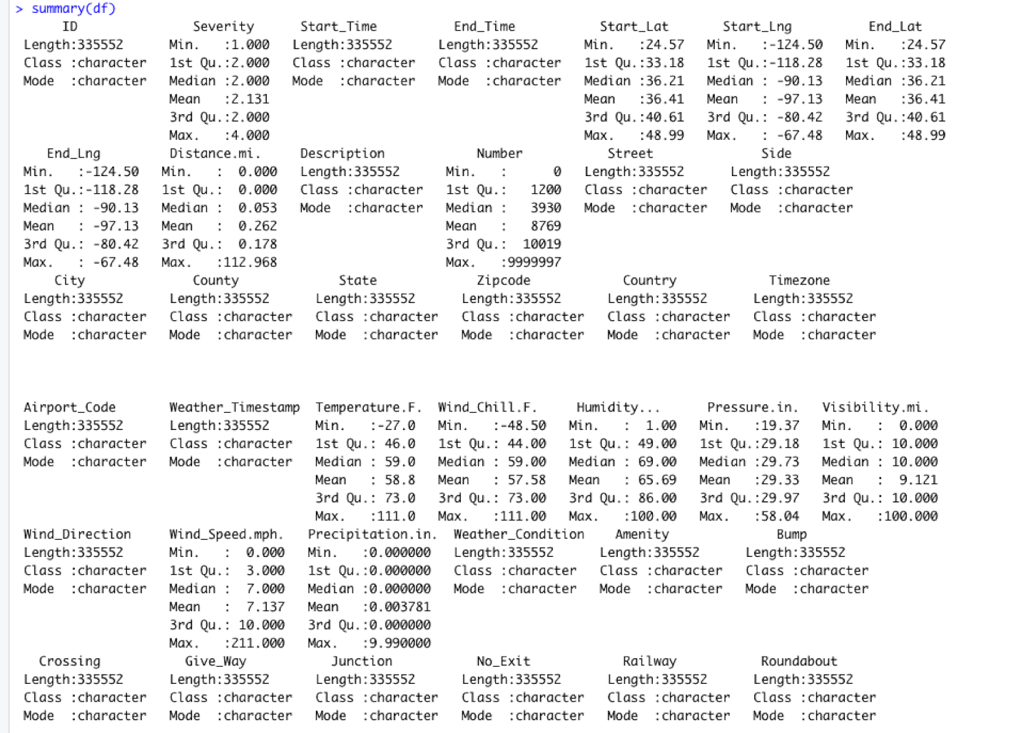

Describe function shows if there are any missing values, number of values and unique values along with mean values.

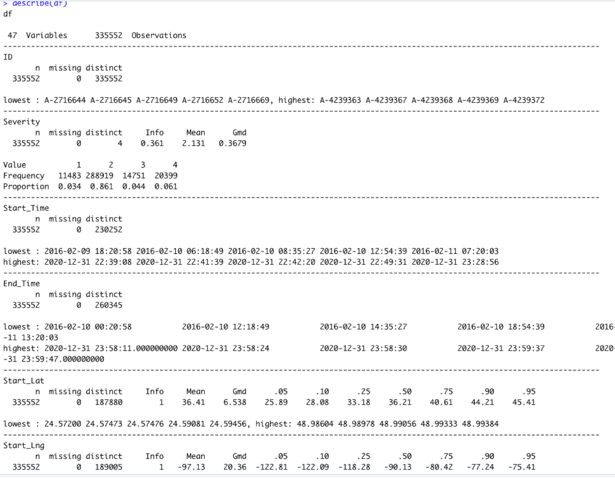

*Below image shows the correlation among the variables. Correlation falls in range of -1 and 1. -1 being perfectly negative correlation and 1 being positive correlation. 0 shows no correlation among the variables.

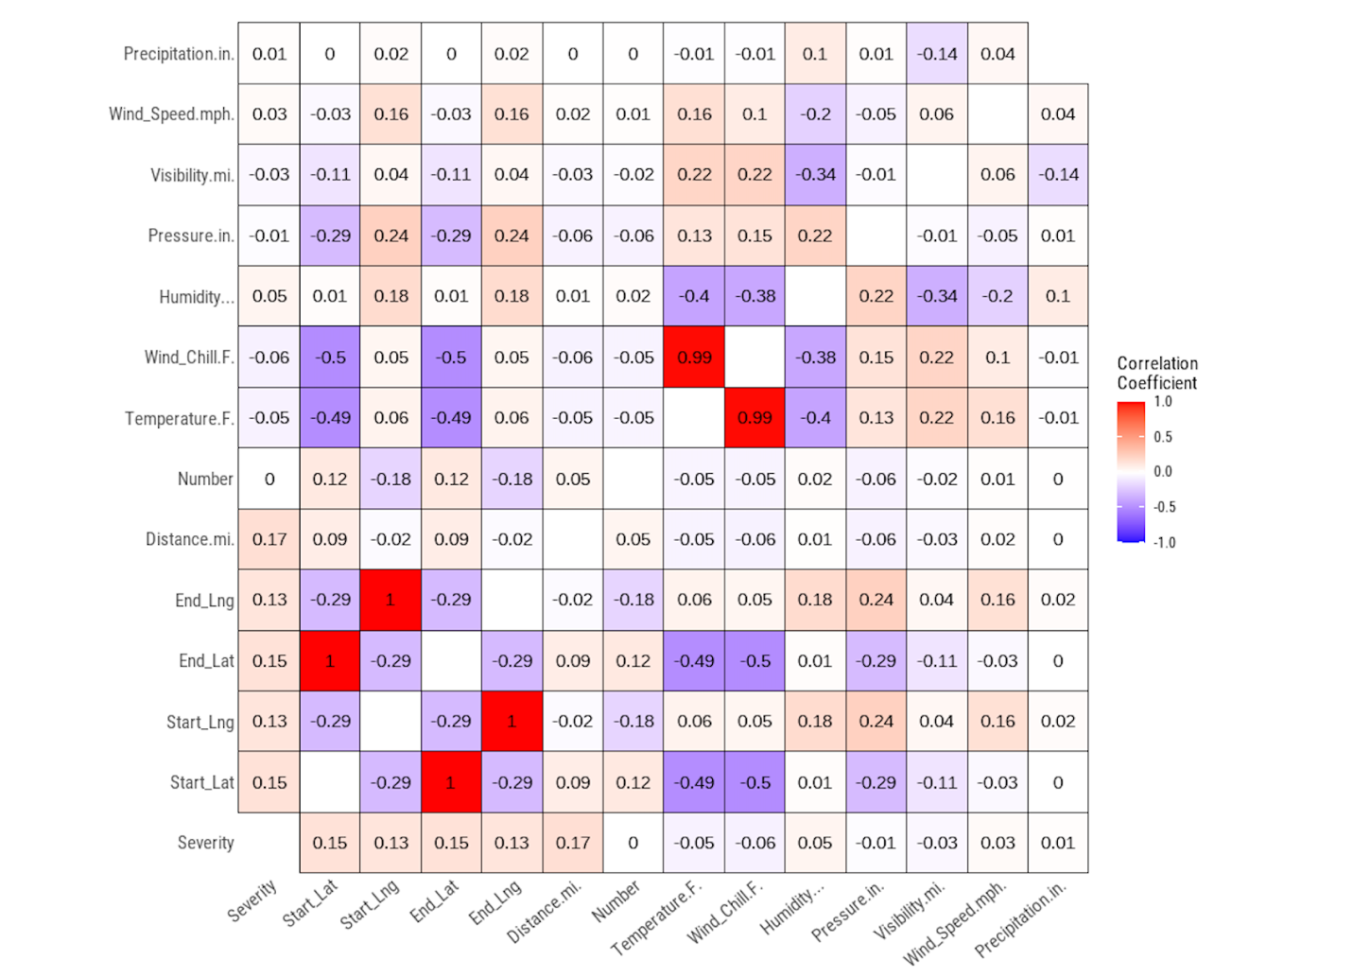

*Below box plots show the outliers which are helpful in understanding the functioning of data.

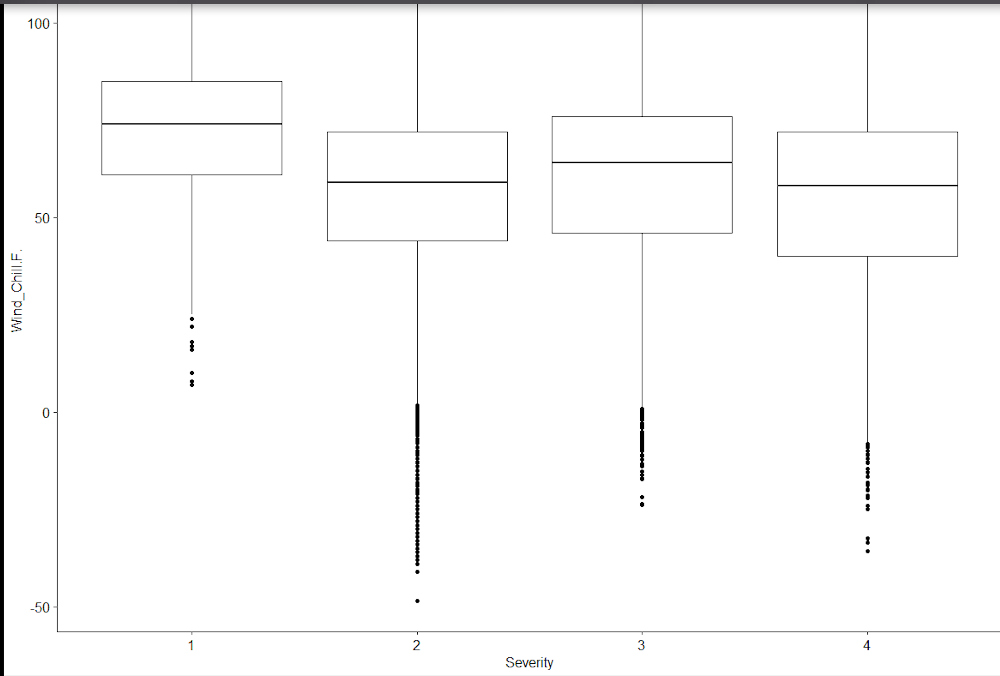

*To understand the normality of the variables, following graphs were plotted for each variable. Then the variable was applied with log transformation and sqrt transformation to identify further normality.

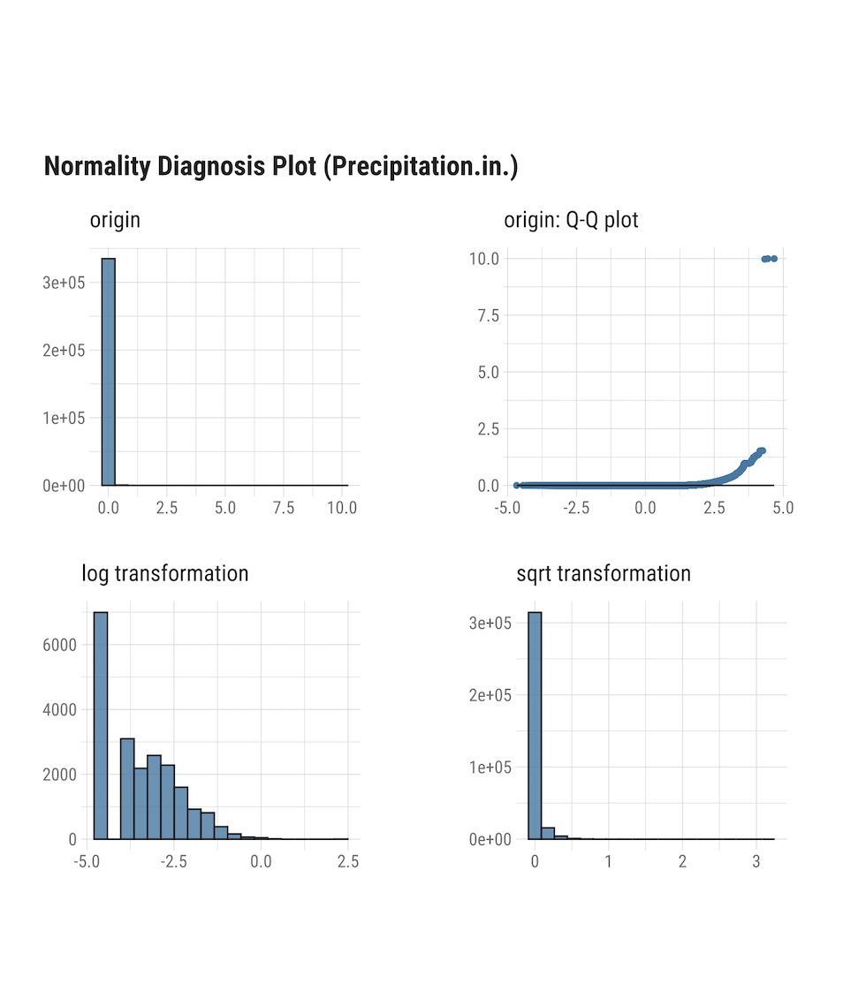

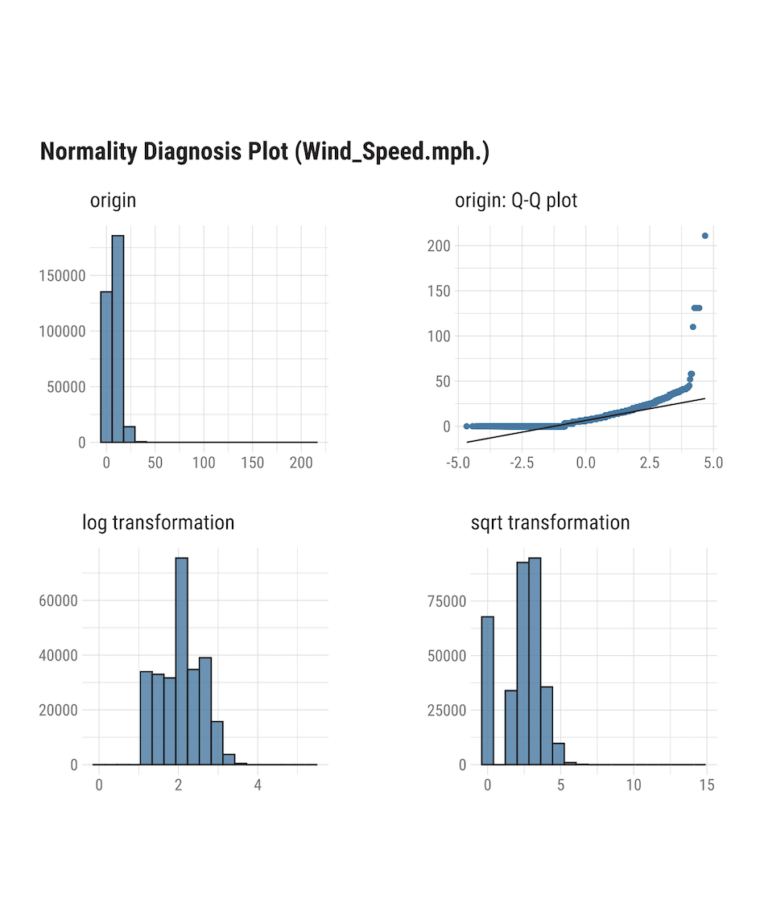

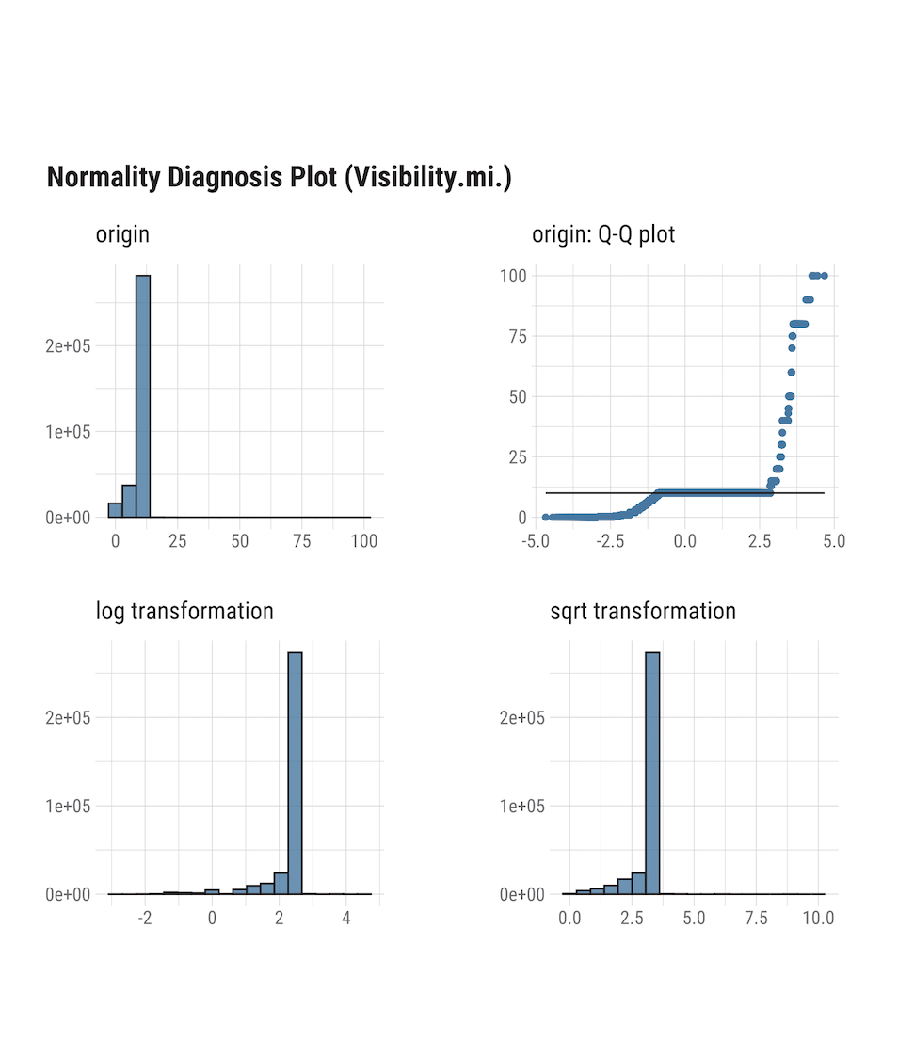

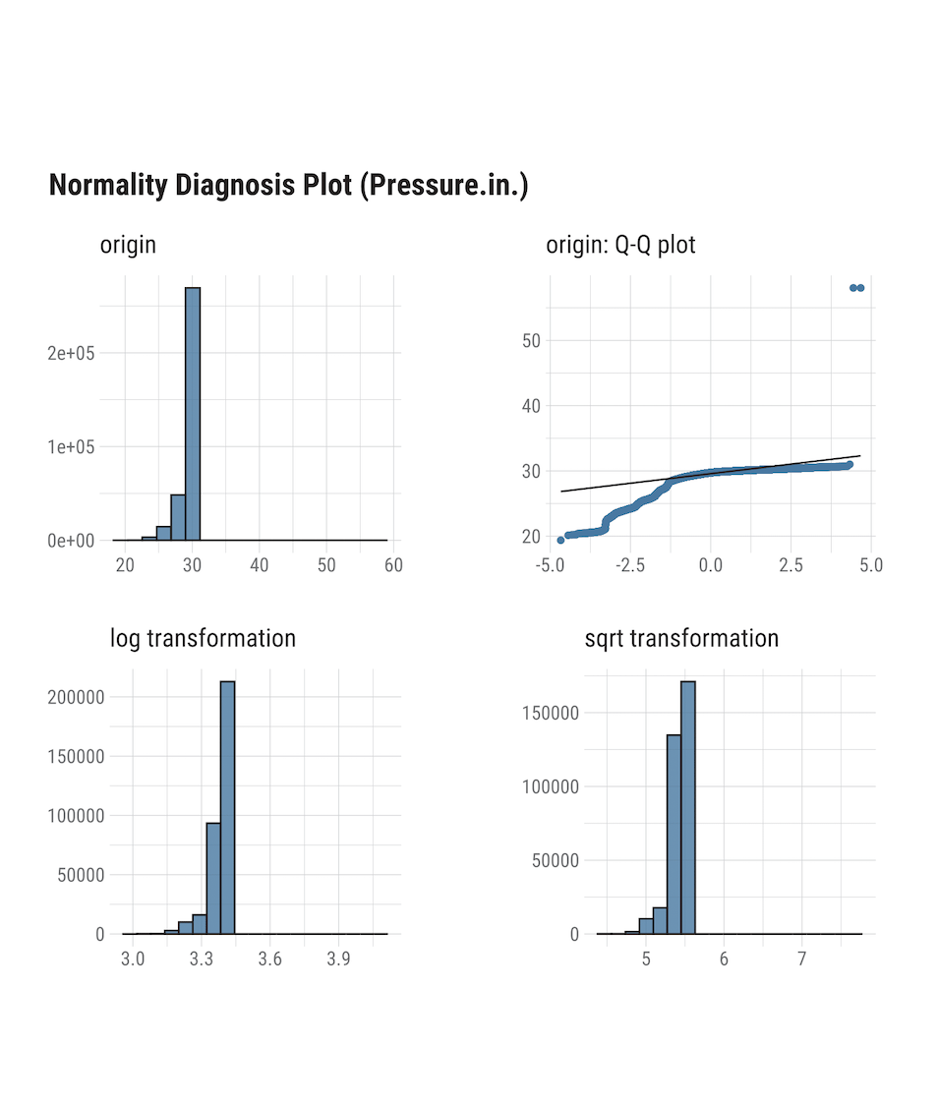

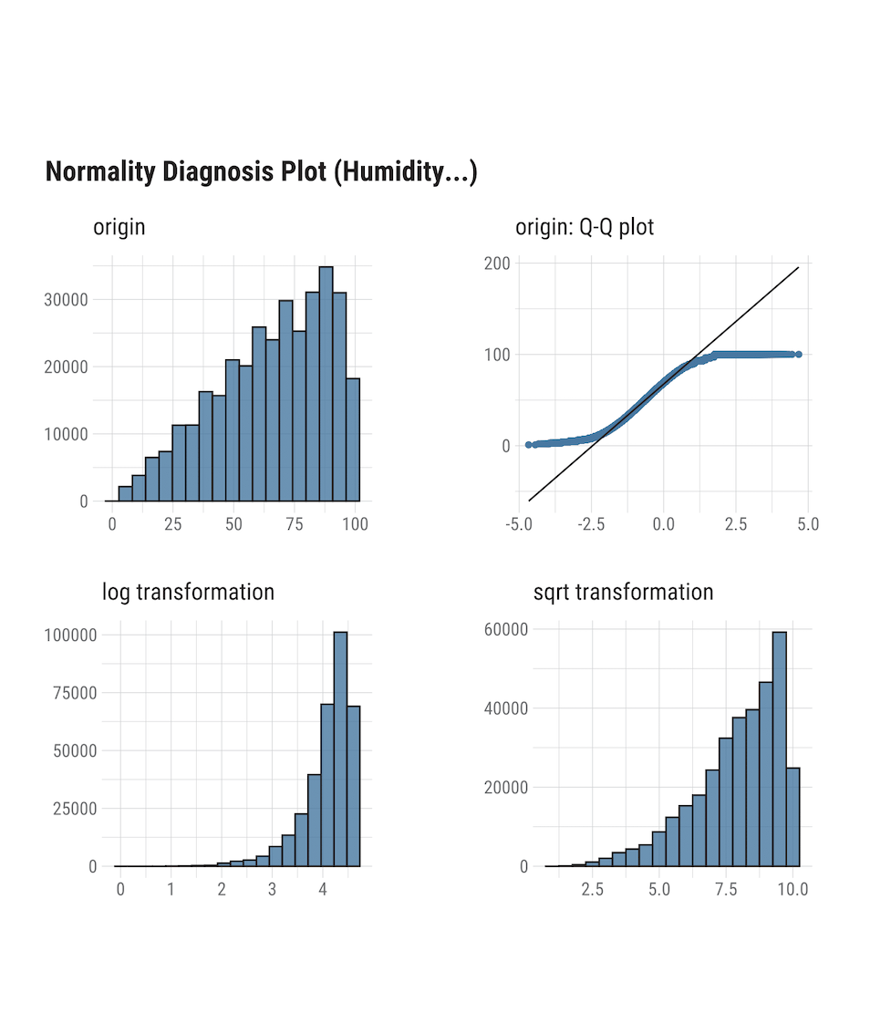

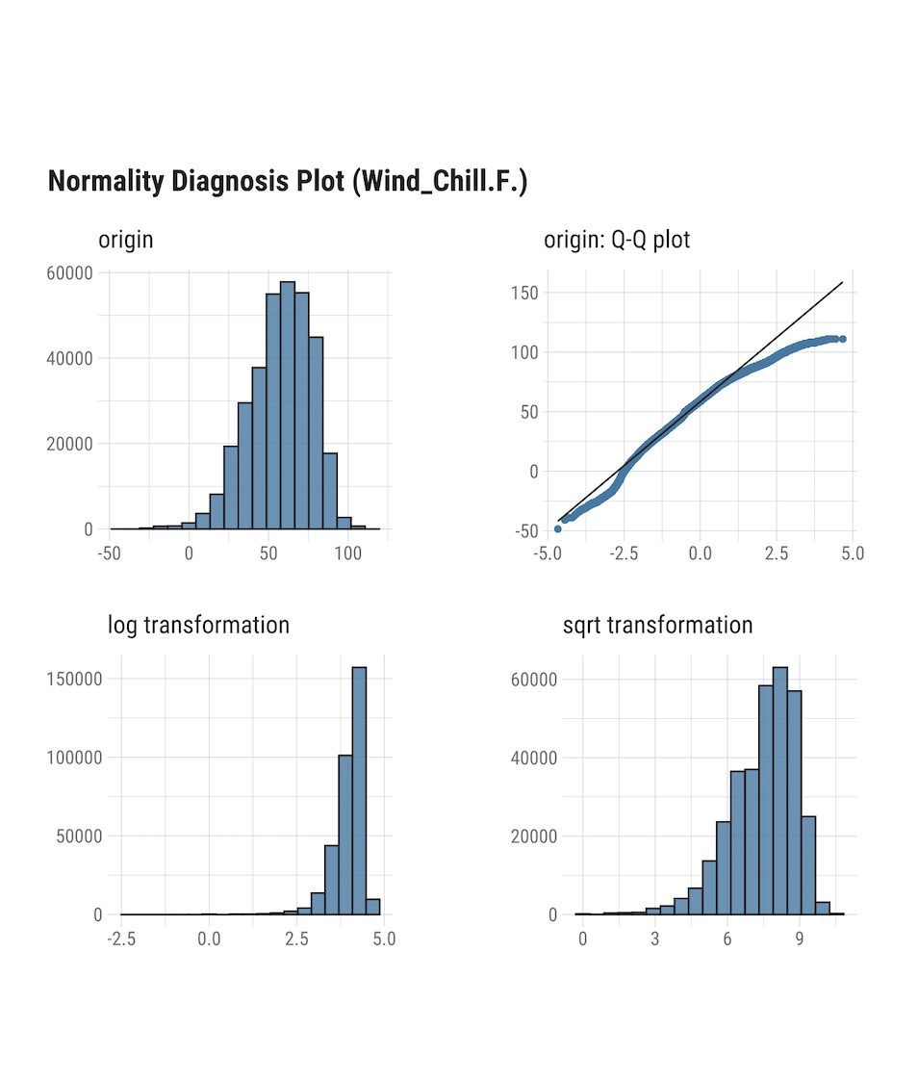

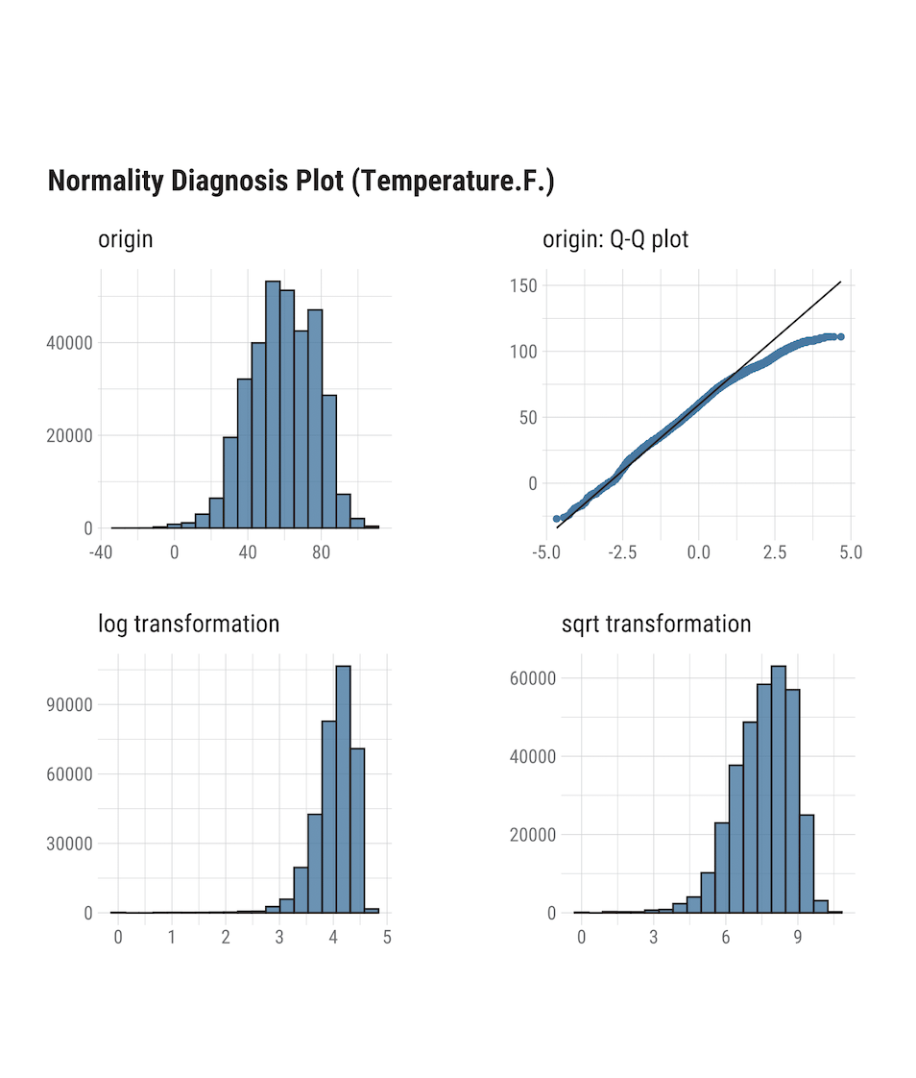

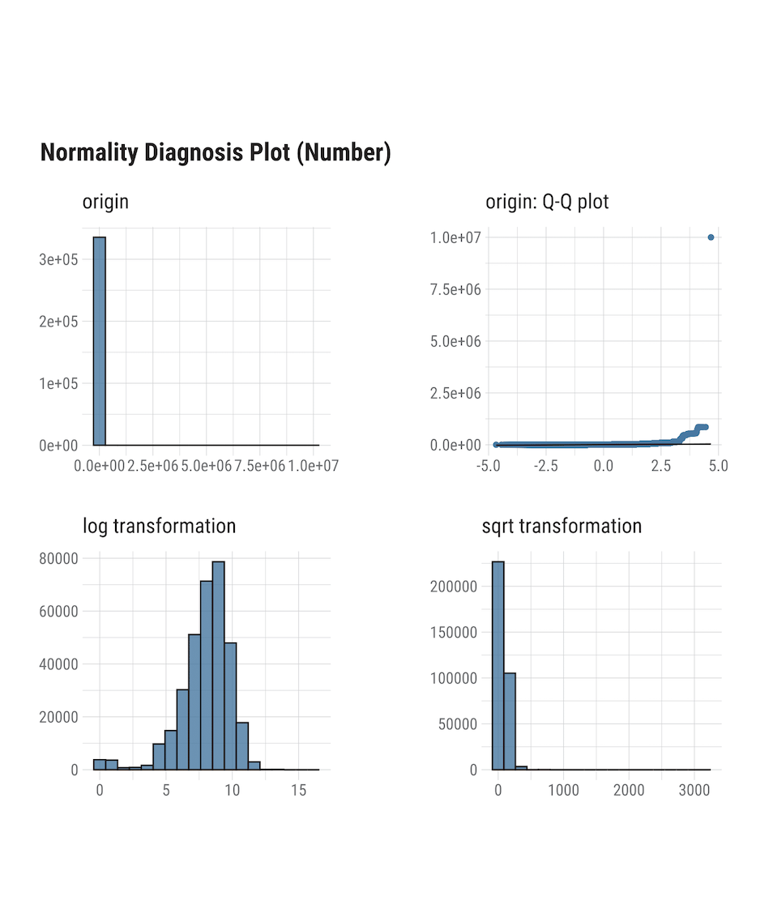

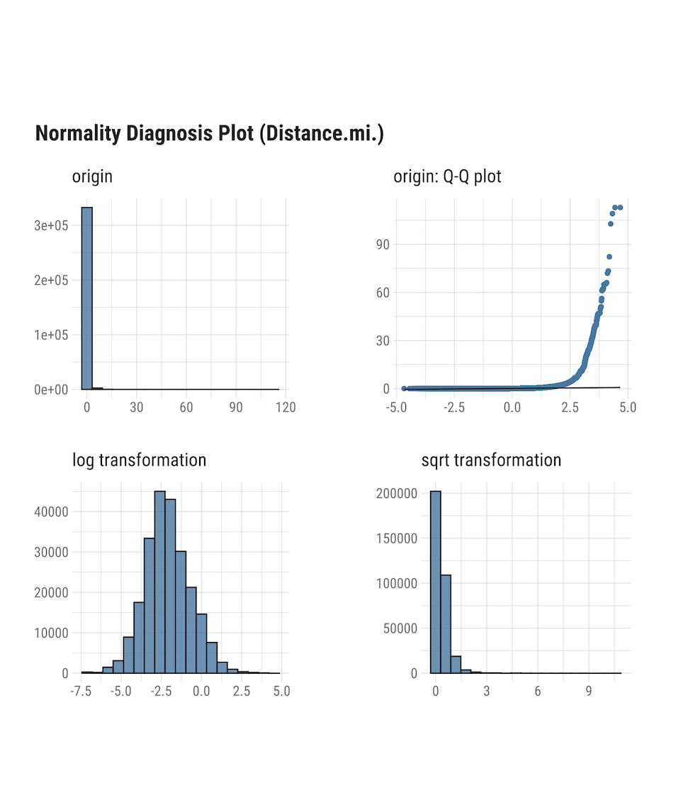

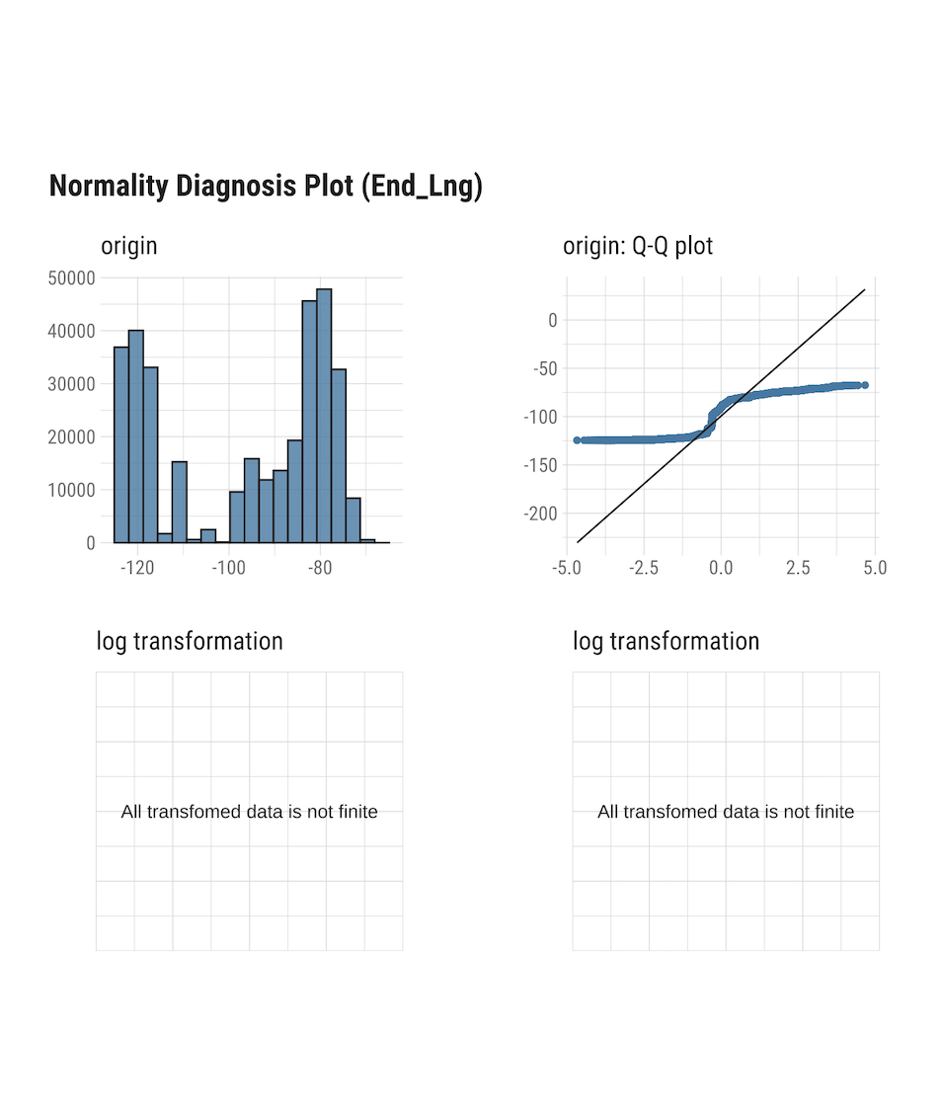

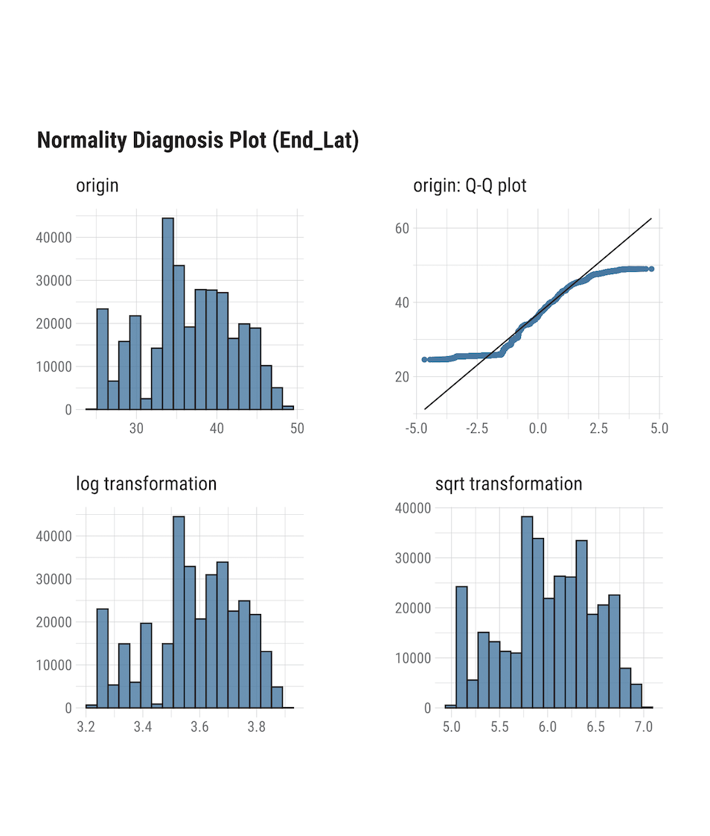

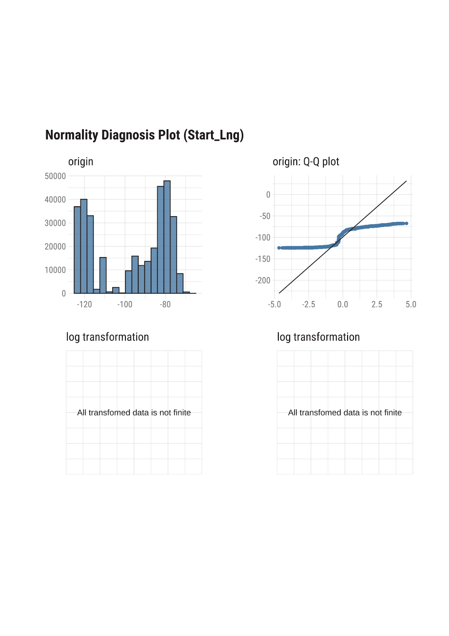

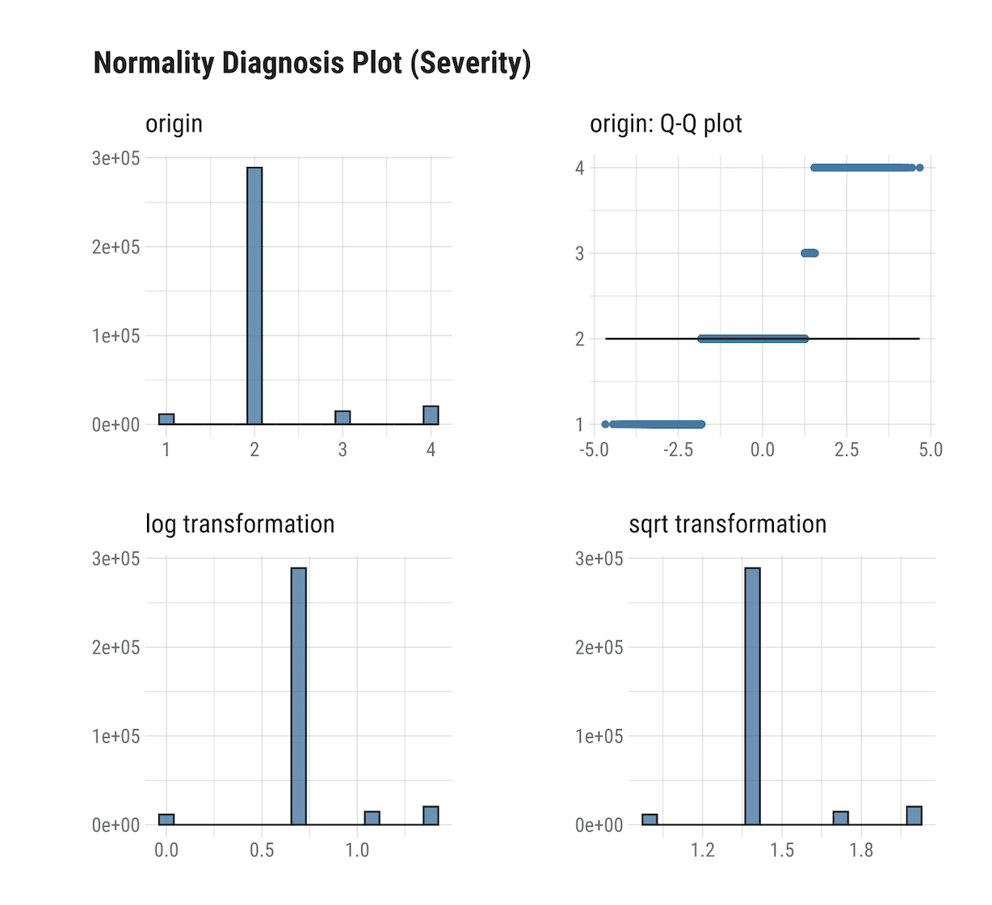

**INITIAL ANALYSIS**

df_for_TSF = read.csv("US_Accidents.csv")

head(df_for_TSF)

df_for_TSF$MY = format(as.Date(df_for_TSF$Start_Time), "%m-%y")

count_accidents_MY = my_func(df_for_TSF,quo(MY))

install.packages("zoo")

library(zoo)

count_accidents_MY <- count_accidents_MY[order(as.yearmon(count_accidents_MY$MY, "%m-%Y")),]

head(count_accidents_MY,20)

summary(count_accidents_MY)

accidents.ts = ts(count_accidents_MY$my_count, start = 2016, end = 2020,frequency = 12)

plot(accidents.ts, xlab = "Time", ylab = "Number of accidents", )

plot(decompose(accidents.ts))

acf(accidents.ts)

pacf(accidents.ts)

install.packages("tseries")

library(tseries)

adf.test(accidents.ts)

seasonplot(accidents.ts, xlab = "Month", ylab = "Number of accidents", main="Seasonal plot", year.labels.left = TRUE, col =1:20, pch = 19)

monthplot(accidents.ts, xlab = "Month", ylab = "Number of accidents", main="Seasonal Standard deviation",xaxt = "n")

axis(1, at = 1:12, labels = month.abb, cex = 0.8)

ntrain = length(accidents.ts) - 12

train.ts = window(accidents.ts, start =c(2016,1), end = c(2016,ntrain))

valid.ts = window(accidents.ts, start =c(2016, ntrain +1 ), end = c(2016,ntrain+ 12))

install.packages("MLmetrics")

library(MLmetrics)

*Following graph is used to visualize number of accidents occurring each year and we can clearly notice the spike in years 2019 and 2020.

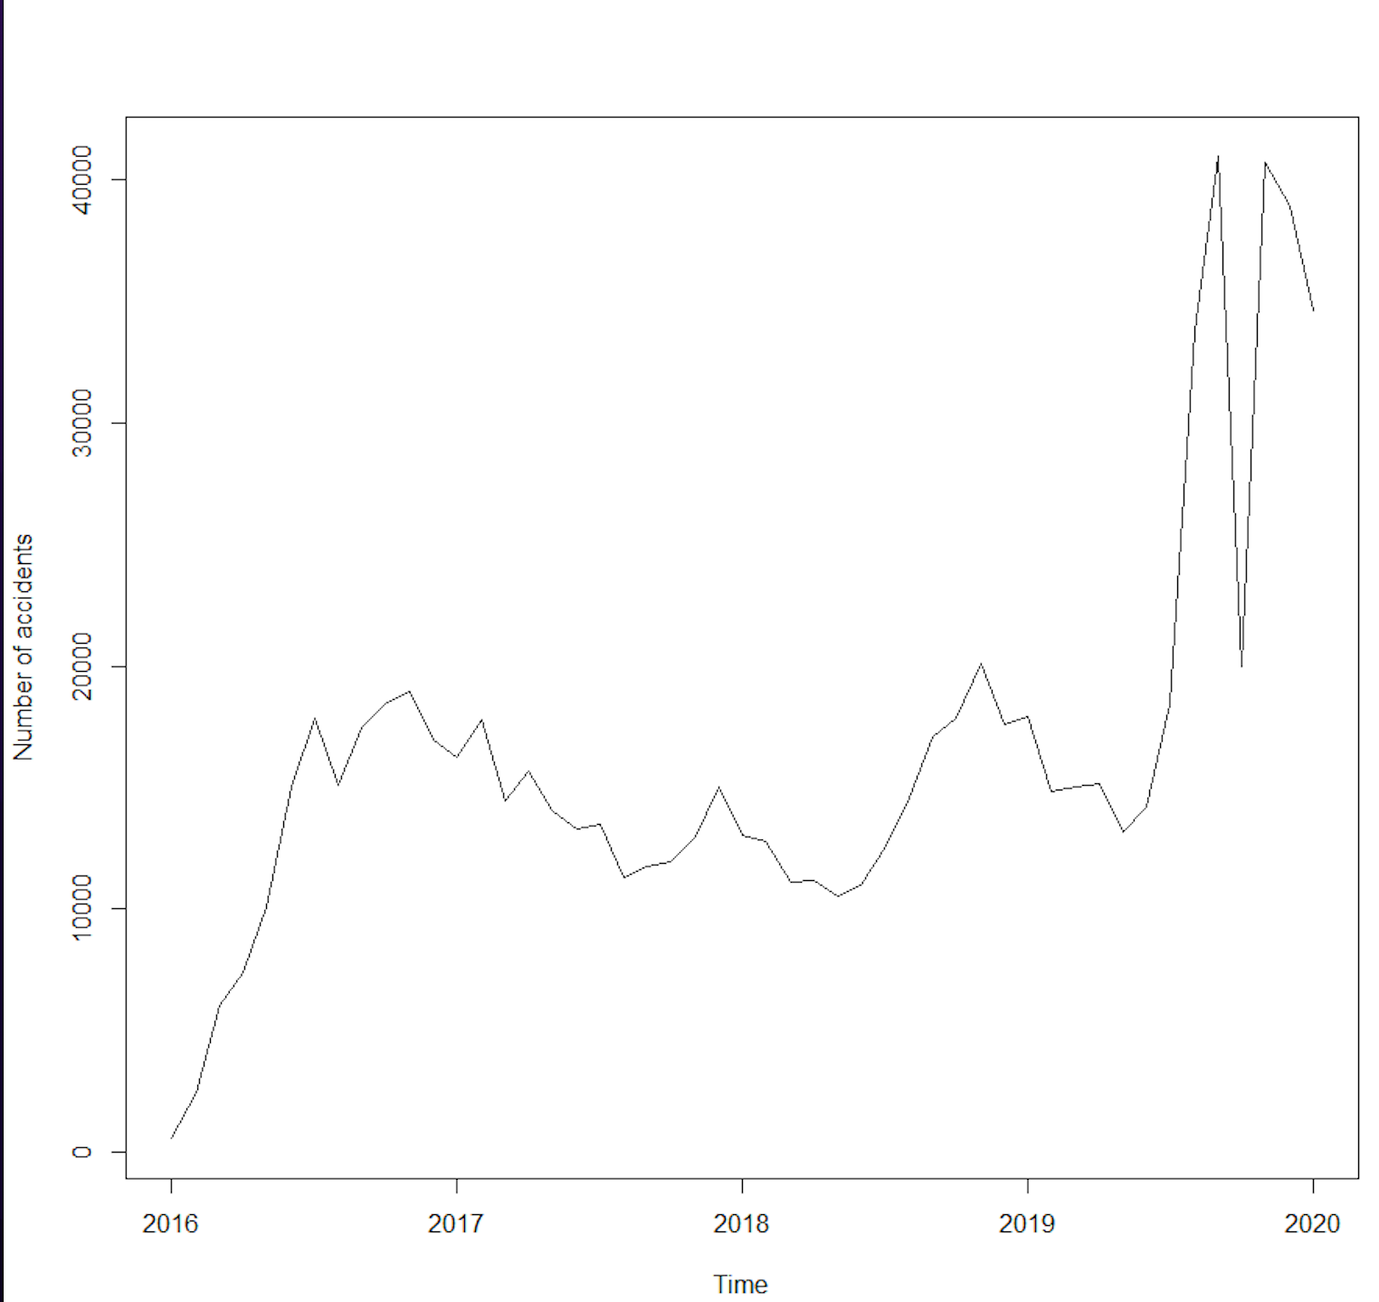

*In the below graph, we can observe clear outliers from 2019 to 2020 which changed the pattern of the trends.

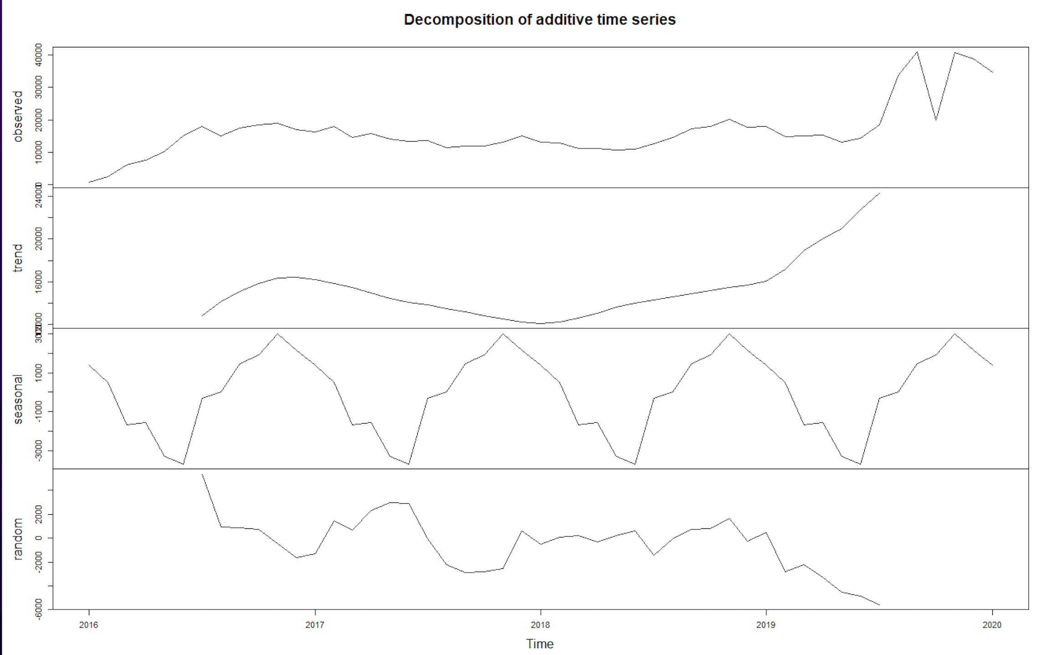

*Following graphs were plotted to visualize auto correlation functions.

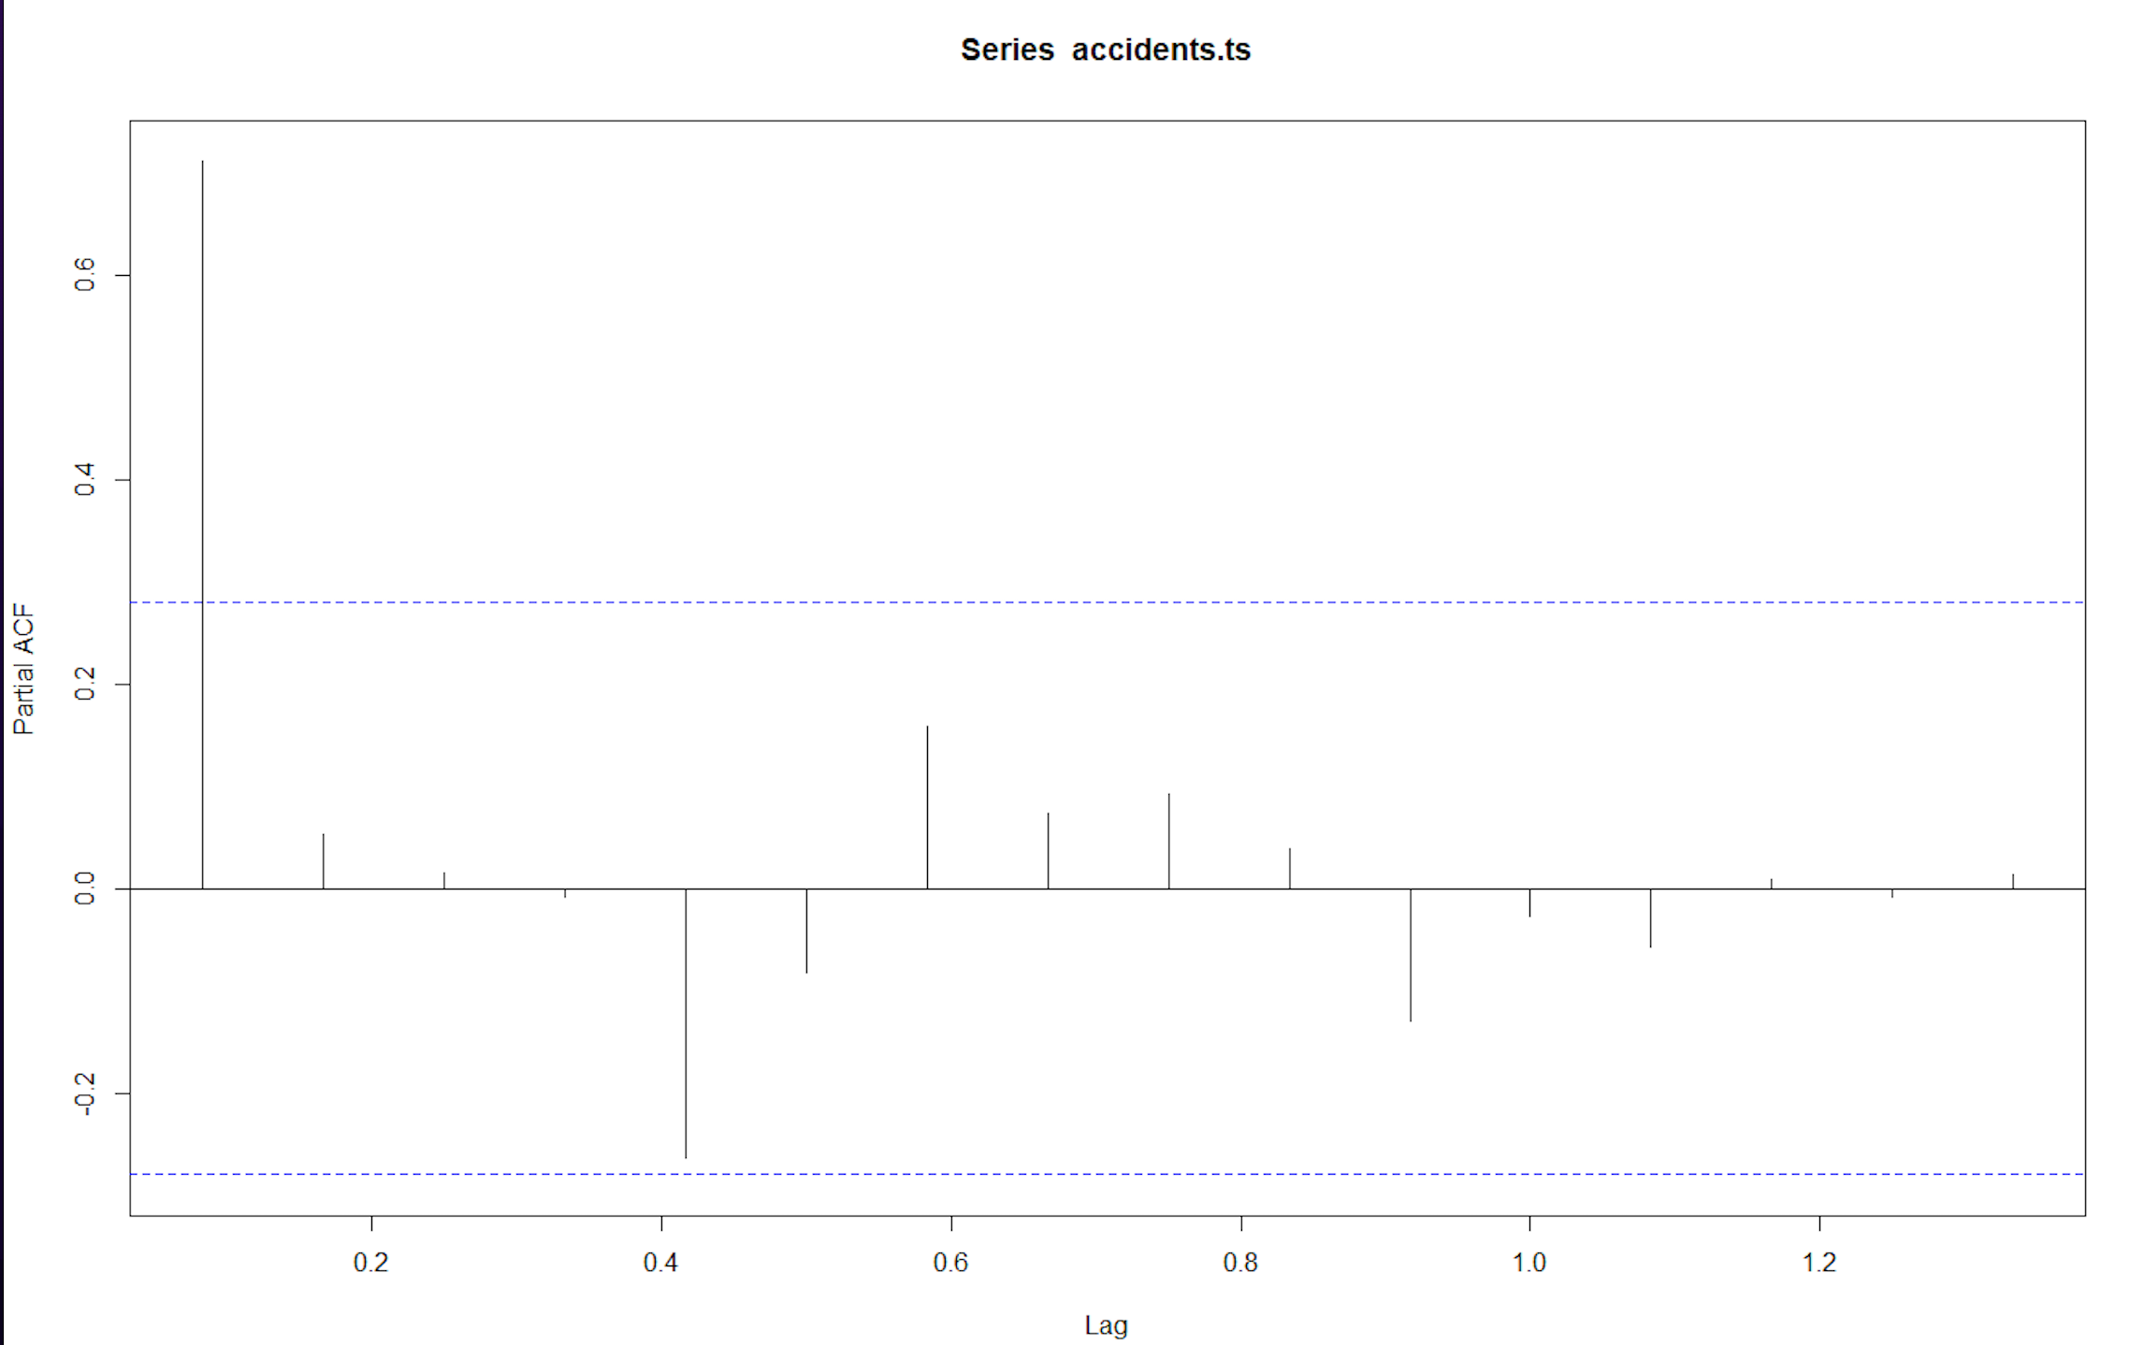

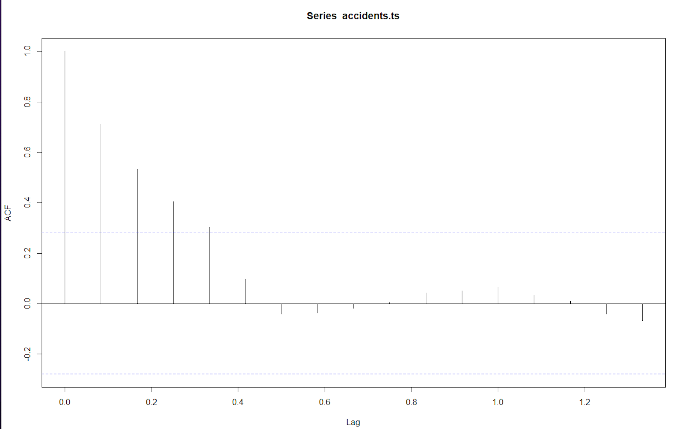

*Below graphs shows number of accidents occurred in each month with respect to each year.

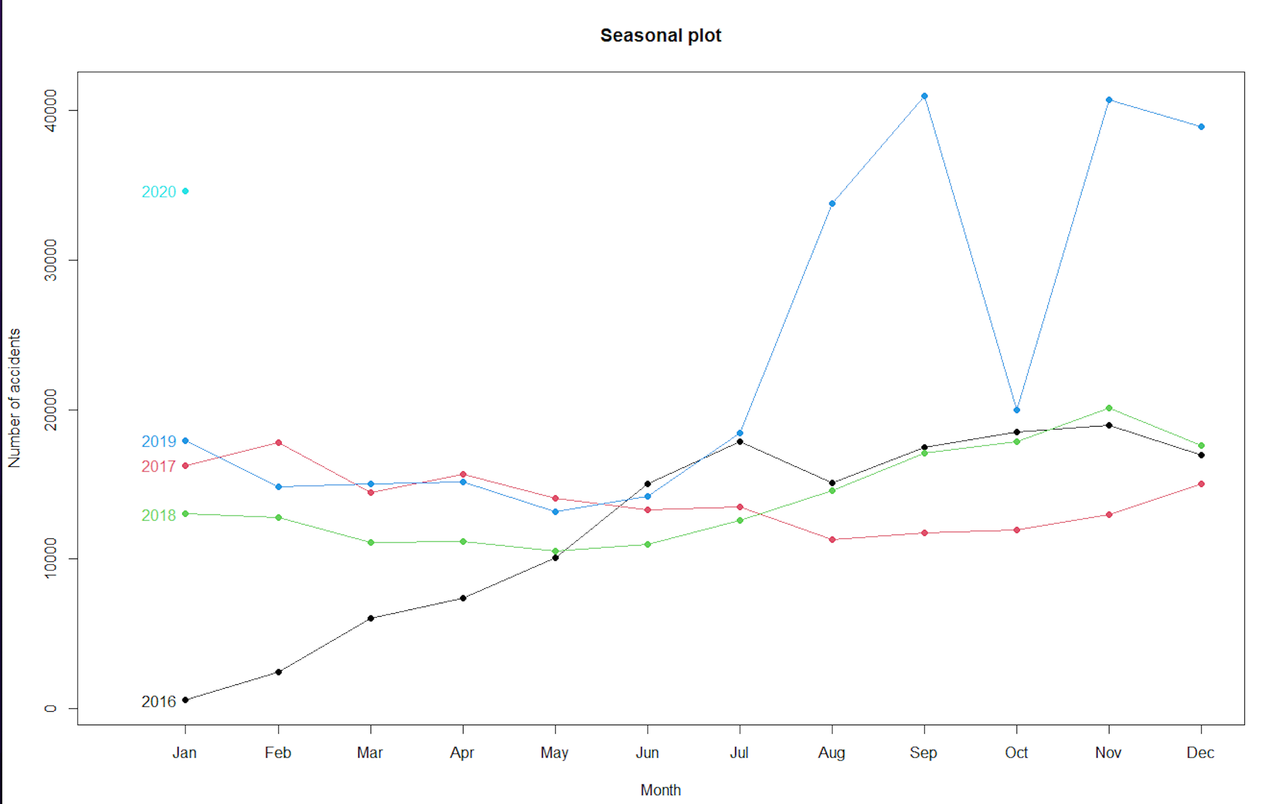

*Below graph shows the number of accidents in each month and we can see that each month crossed mean number of accidents for each year.

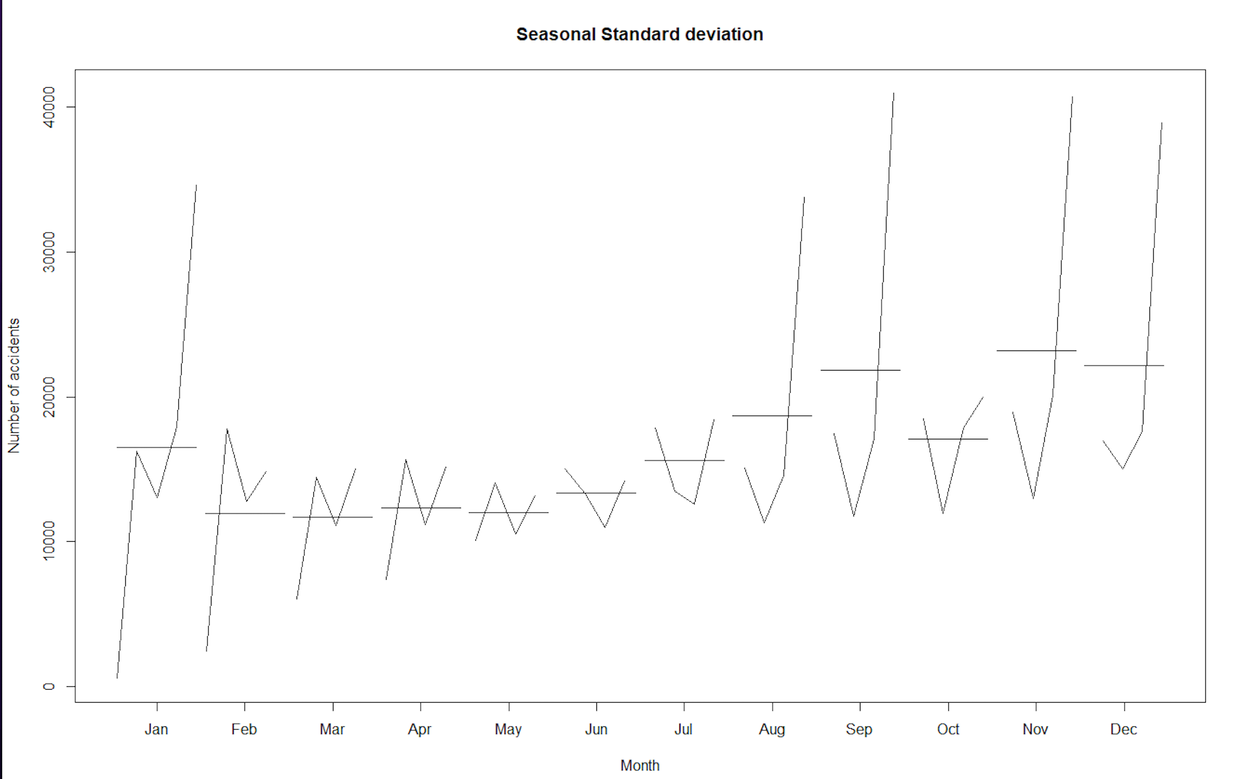

library(forecast)

**Naive model**

model_naive = snaive(train.ts, h = 12)

MAPE(model_naive$mean, 12)*100

accuracy(model_naive, valid.ts)

plot(accidents.ts, xlab = "Time", ylab = "Number of accidents", )

lines(model_naive$mean, col="red", lwd=2)

Naive forecasting models are based exclusively on historical observation of sales or other variables, such as earning and cash flows. They do not attempt to explain the underlying causal relationships that produce the variable being forecast.

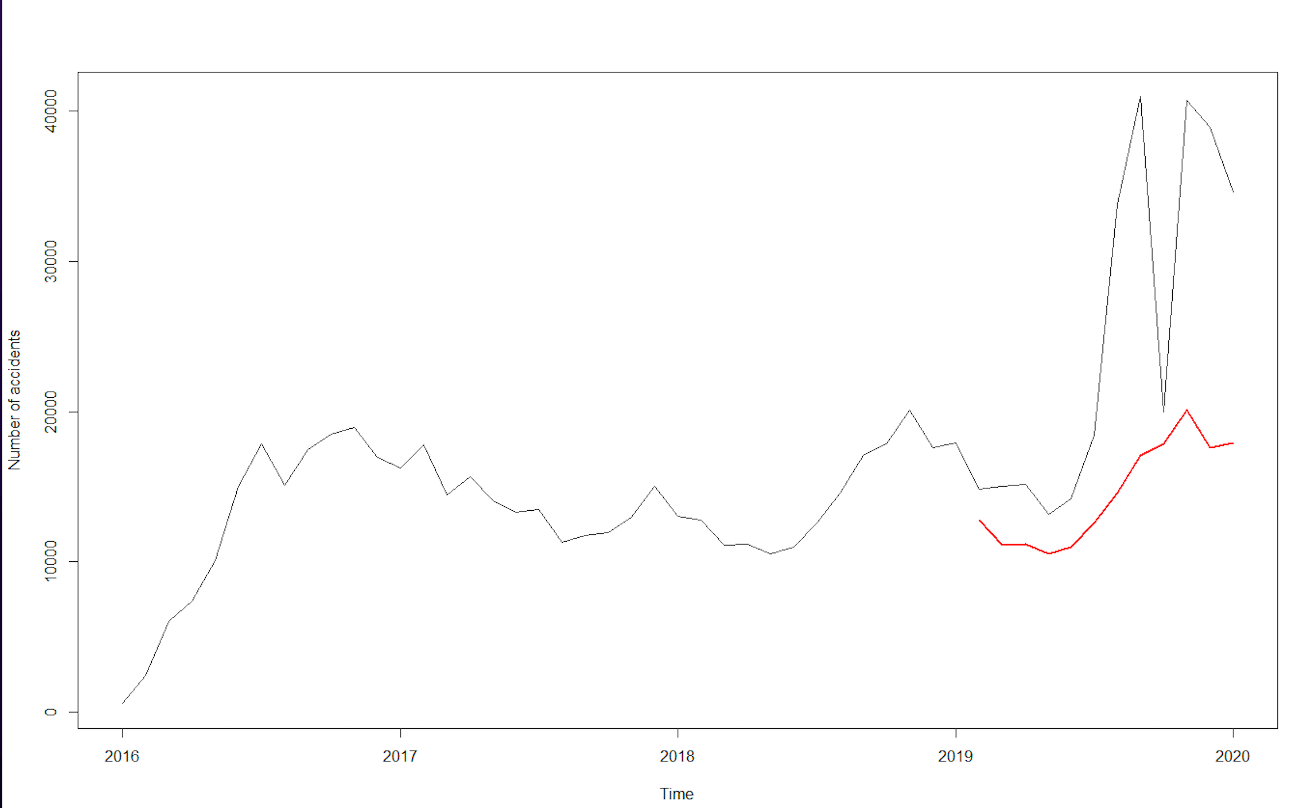

**ARIMA model**

ARIMA, short for ‘Auto Regressive Integrated Moving Average’ is actually a class of models that ‘explains’ a given time series based on its own past values, that is, its own lags and the lagged forecast errors, so that equation can be used to forecast future values.

model_arima = auto.arima(train.ts)

summary(model_arima)

model_arima_pred = forecast(model_arima, h= 12, level = 0)

accuracy(model_arima_pred, valid.ts)

Box.test(model_arima$residuals)

plot(model_arima_pred)

pred = predict(auto.arima(train.ts), n.ahead = 10*12)

plot(accidents.ts, xlab = "Time", ylab = "Number of accidents", xlim = c(2016,2027))

lines(pred$se, col="red", lwd=2)

Forecast_val = ((forecast(accidents.ts, h=30)))

plot(accidents.ts, xlab = "Time", ylab = "Number of accidents", xlim = c(2016,2027))

lines(Forecast_val$mean, col="red", lwd=2)

Forecast_val2 = (forecast(auto.arima(train.ts), h=30))

plot(accidents.ts, xlab = "Time", ylab = "Number of accidents", xlim = c(2016,2027))

lines(Forecast_val2$mean, col="red", lwd=2)

highest_accident_zipcode=my_func(df, quo(Zipcode))

head(highest_accident_zipcode, 20)

ggplot(data=head(highest_accident_zipcode, 20), aes(x=Zipcode, y=my_count)) +

geom_bar(stat="identity", fill="steelblue", width = 1)+

geom_text(aes(label=my_count), vjust=1.6, color="white", size=3.5)+

theme_minimal()

highest_accident_area = my_func(df, quo(Street))

head(highest_accident_area, 20)

ggplot(data=head(highest_accident_area, 20), aes(x=Street, y=my_count)) +

geom_bar(stat="identity", fill="steelblue", width = 1)+

geom_text(aes(label=my_count), vjust=1.6, color="white", size=3.5)+

theme_minimal()

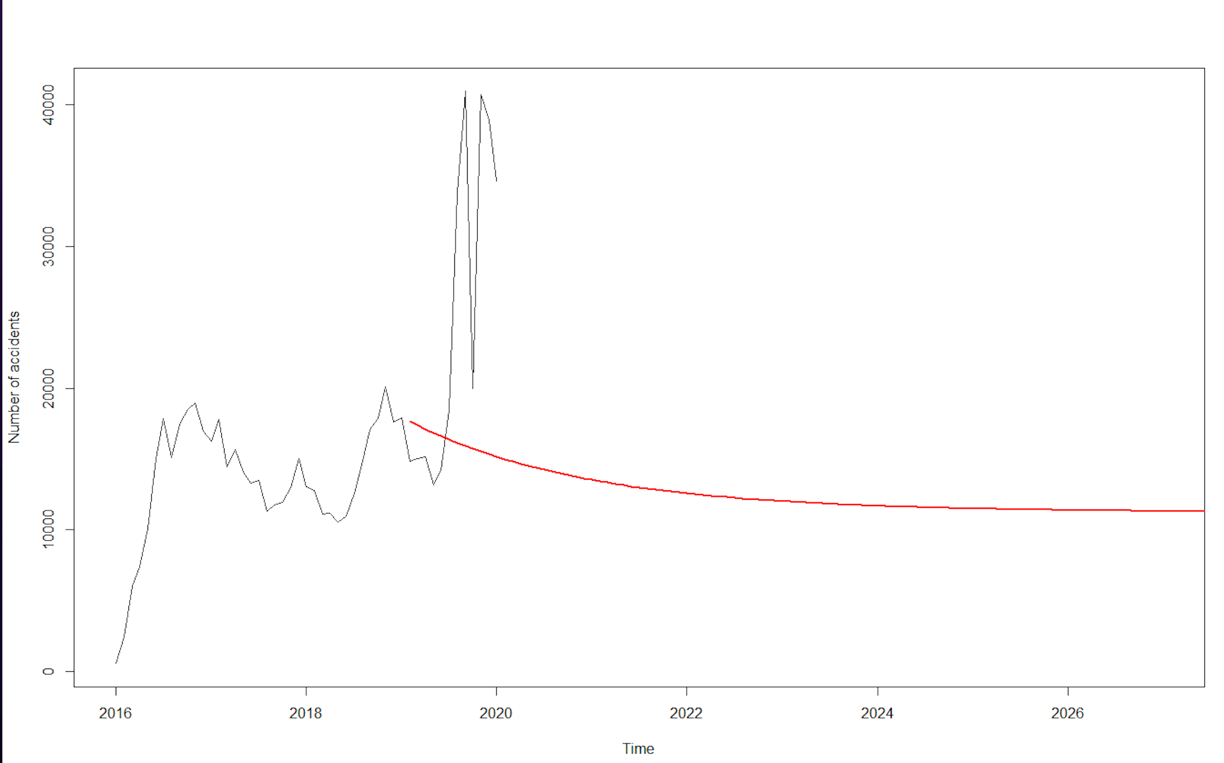

**KRIGING MODEL**

Kriging is an advanced geostatistical procedure that generates an estimated surface from a scattered set of points with z-values. Unlike other interpolation methods in the Interpolation toolset, to use the [Kriging](https://desktop.arcgis.com/en/arcmap/10.3/tools/3d-analyst-toolbox/kriging.htm) tool effectively involves an interactive investigation of the spatial behavior of the phenomenon represented by the z-values before you select the best estimation method for generating the output surface.

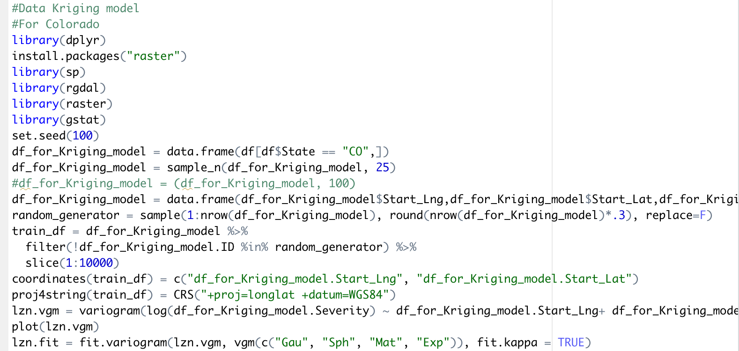

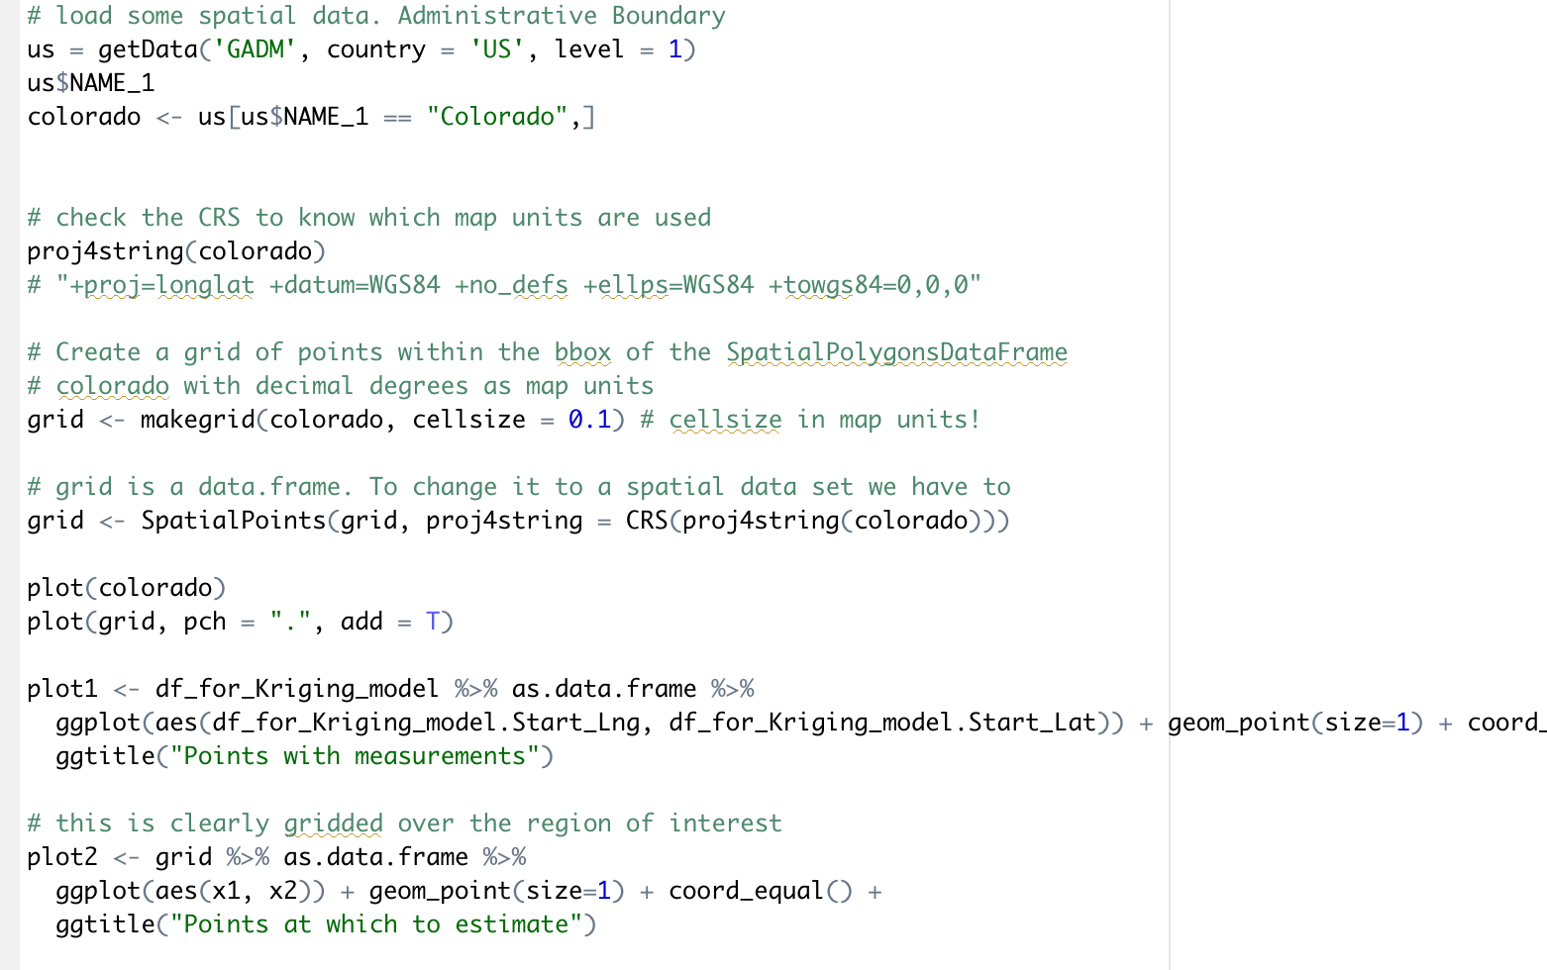

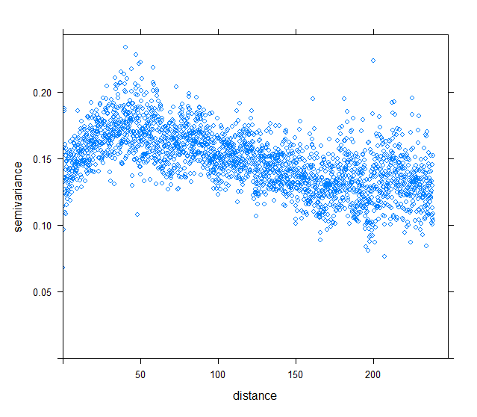

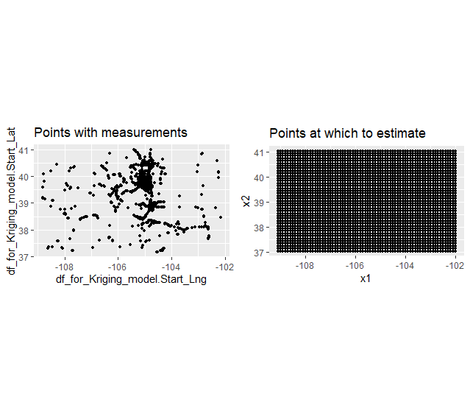

*The heat map below shows the frequency of accidents in Colorado. As the color intensifies, it represents occurrence of more accidents.

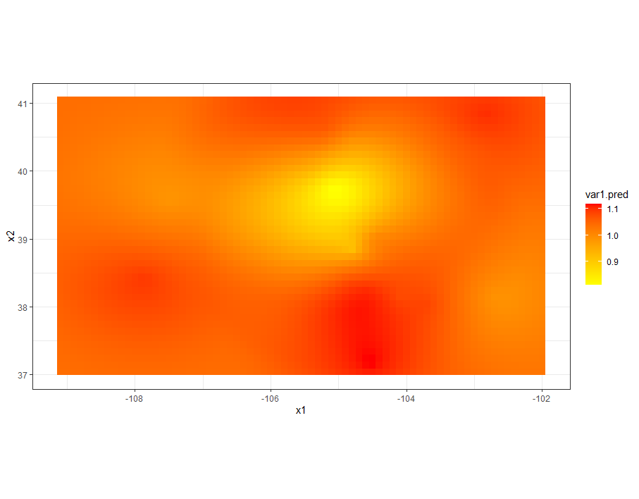

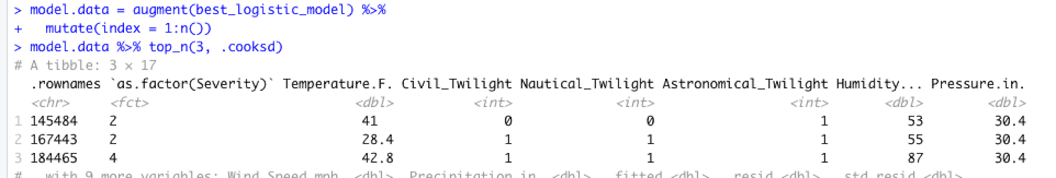

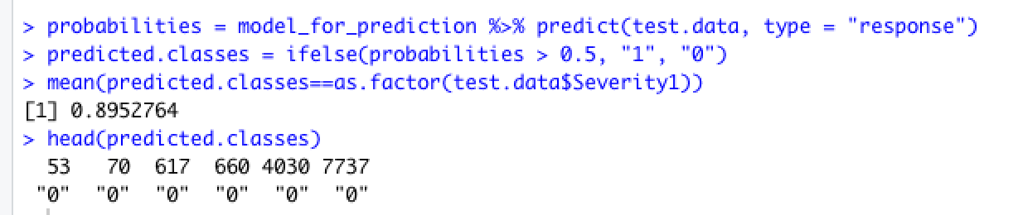

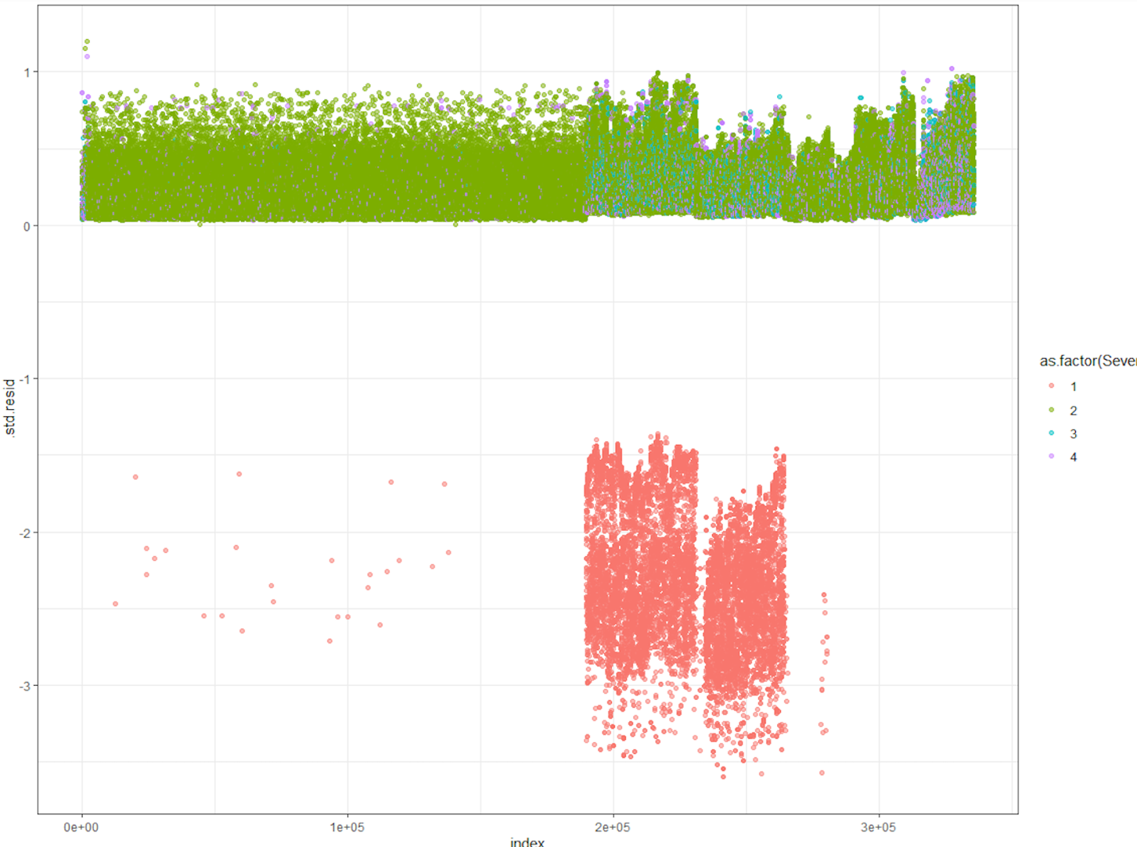

**Regression Model:**

***Linear Regression***

model=lm(Severity~Distance.mi.+Temperature.F.+ Humidity... +Pressure.in. +Visibility.mi.+Wind_Speed.mph.+ Precipitation.in.,data=df)

stepAIC(model,direction = "both",trace = FALSE)

summary(model)

install.packages("leaps")

library(leaps)

regsubsets.out <-regsubsets(Severity~.,data =df,nbest = 1, # 1 best model for each number of predictors

nvmax = NULL, # NULL for no limit on number of variables

force.in = NULL, force.out = NULL,

method = "exhaustive")

summary_best_subset <- summary(regsubsets.out)

as.data.frame(summary_best_subset$outmat)

***Logistic Regression***

model = glm(as.factor(Severity) ~ Temperature.F.+ Sunrise_Sunset + Civil_Twilight + Nautical_Twilight + Astronomical_Twilight +

Side_isRight + Humidity... + Pressure.in. + Visibility.mi.+ Wind_Speed.mph.+ Precipitation.in., data = df, family = binomial)

stepAIC(model,direction = "both",trace = FALSE)

#best model

best_logistic_model = glm(formula = as.factor(Severity) ~ Temperature.F. + Civil_Twilight +

Nautical_Twilight + Astronomical_Twilight + Humidity... +

Pressure.in. + Wind_Speed.mph. + Precipitation.in., family = binomial,

data = df)

summary(best_logistic_model)

plot(best_logistic_model)

car::vif(best_logistic_model)

anova(best_logistic_model,test = "Chisq")

library(car)

library(lmtest)

dwtest(best_logistic_model)

library(tidyverse)

library(broom)

theme_set(theme_classic())

probabilities = predict(best_logistic_model, type = "response")

predicted.classes = ifelse(probabilities > 0.5, "pos", "neg")

head(predicted.classes)

plot(best_logistic_model, which = 4, id.n = 3)

#

install.packages("broom")

library(broom)

library(ggplot2)

model.data = augment(best_logistic_model) %>%

mutate(index = 1:n())

model.data %>% top_n(3, .cooksd)

ggplot(model.data, aes(index, .std.resid)) +

geom_point(aes(color = `as.factor(Severity)`), alpha = .5) +

theme_bw()

car::vif(best_logistic_model)

df$Severity1 = as.integer(df$Severity >2)

model_isSevere = glm(as.factor(Severity1) ~ Temperature.F.+ Sunrise_Sunset + Civil_Twilight + Nautical_Twilight + Astronomical_Twilight +

Side_isRight + Humidity... + Pressure.in. + Visibility.mi.+ Wind_Speed.mph.+ Precipitation.in., data = df, family = binomial)

stepAIC(model_isSevere,direction = "both",trace = FALSE)

df2=df

library(tidyverse)

library(caret)

set.seed(12367)

training.samples = as.factor(df2$Severity1) %>%

createDataPartition(p = 0.8, list = FALSE)

train.data = df2[training.samples, ]

test.data = df2[-training.samples, ]

model_for_prediction = glm(formula = as.factor(Severity1) ~ Temperature.F. + Sunrise_Sunset +

Civil_Twilight + Astronomical_Twilight + Side_isRight + Humidity... +

Pressure.in. + Visibility.mi. + Wind_Speed.mph. + Precipitation.in.,

family = binomial, data = df2)

summary(model_for_prediction)

probabilities = model_for_prediction %>% predict(test.data, type = "response")

predicted.classes = ifelse(probabilities > 0.5, "1", "0")

head(predicted.classes)

# Model accuracy

mean(predicted.classes==as.factor(test.data$Severity1))

my_func <- function(df, group){

df %>%

group_by(!!group) %>%

summarise(my_count = n()) %>%

arrange(desc(my_count))

}

my_group = quo(State)

highest_accident_state=my_func(df, my_group)

ggplot(data=highest_accident_state, aes(x=State, y=my_count)) +

geom_bar(stat="identity", fill="steelblue", width = 1)+

geom_text(aes(label=my_count), vjust=1.6, color="white", size=1.5)+

theme_minimal()

install.packages("lubridate")

library(lubridate)

library(readr)

accidents_new = df %>%

mutate(startHr=hour(Start_Time))

head(accidents_new)

accidents_count = accidents_new %>%

count(startHr)

head(accidents_count)

accidents_count

ggplot(accidents_count, aes(startHr, n)) + geom_point() +geom_path()

The first model below is used to reach the best model by trying combination of various variables and stepAIC which shows the composition of best model.

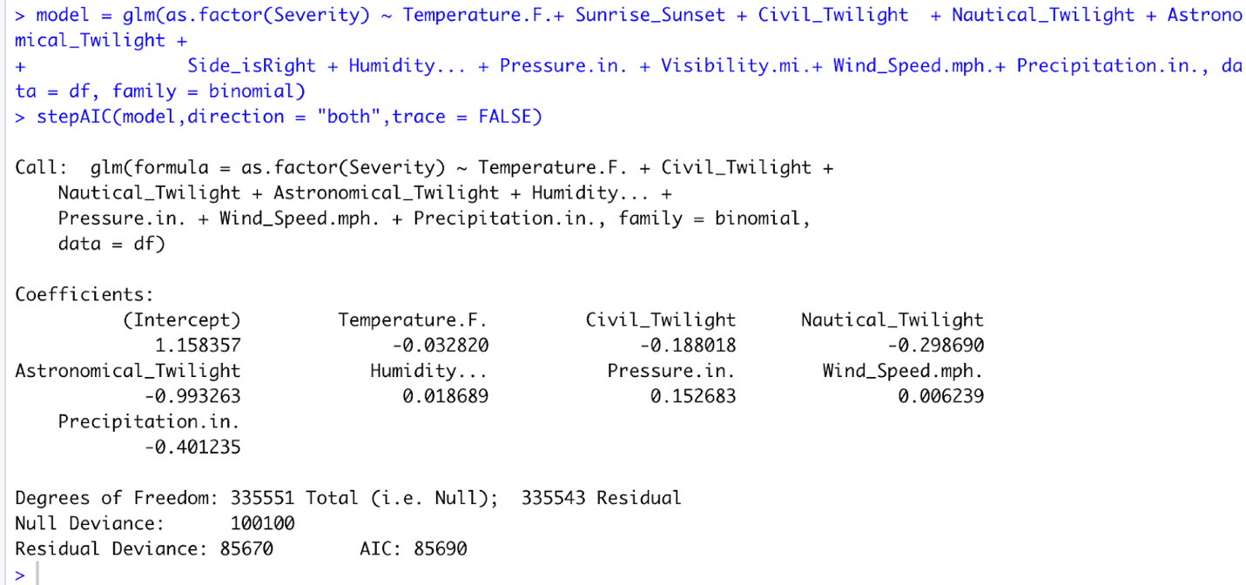

*Below output shows the best model which was identified using stepAIC function.We can observe the least AIC value in it.

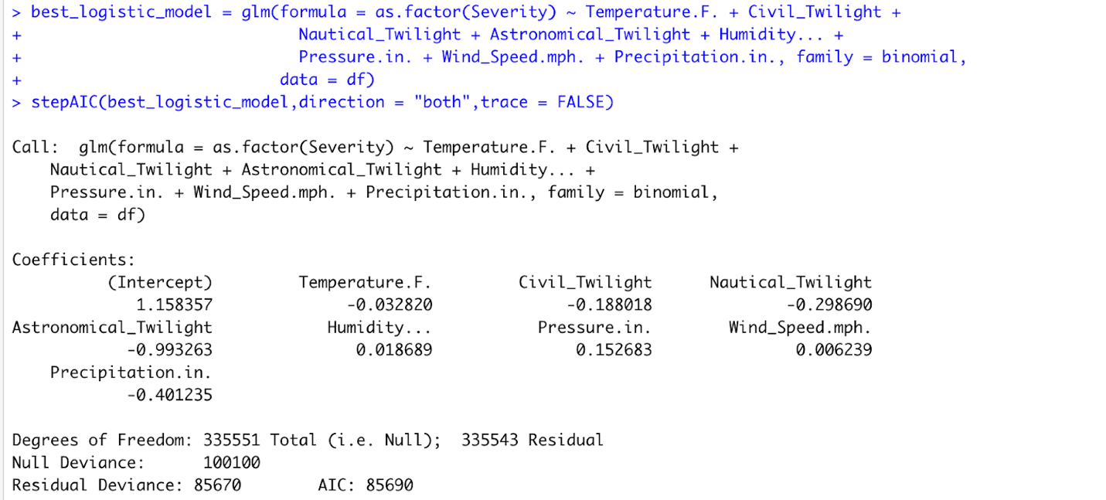

The Durbin Watson (DW) statistic is a test for [autocorrelation](https://www.investopedia.com/terms/a/autocorrelation.asp) in the residuals from a statistical model or [regression analysis](https://www.investopedia.com/terms/r/regression.asp). The Durbin-Watson statistic will always have a value ranging between 0 and 4. A value of 2.0 indicates there is no autocorrelation detected in the sample. Values from 0 to less than 2 point to positive autocorrelation and values from 2 to 4 means negative autocorrelation.

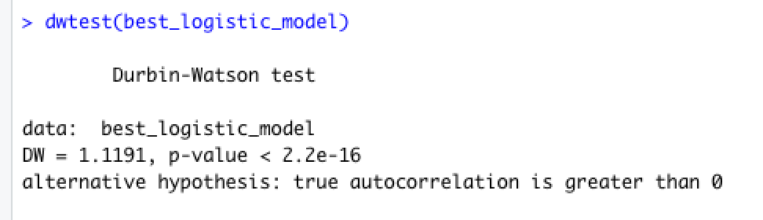

*Below output shows the details of our best model. We can observe all variables to be significant and least AIC value.

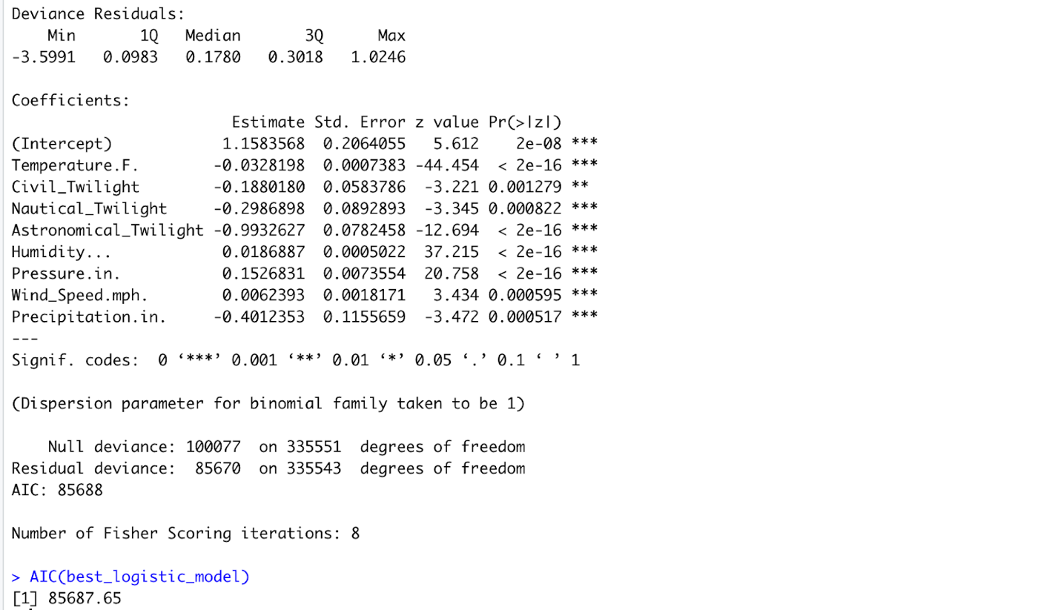

*Anova test can identify significance of variables.

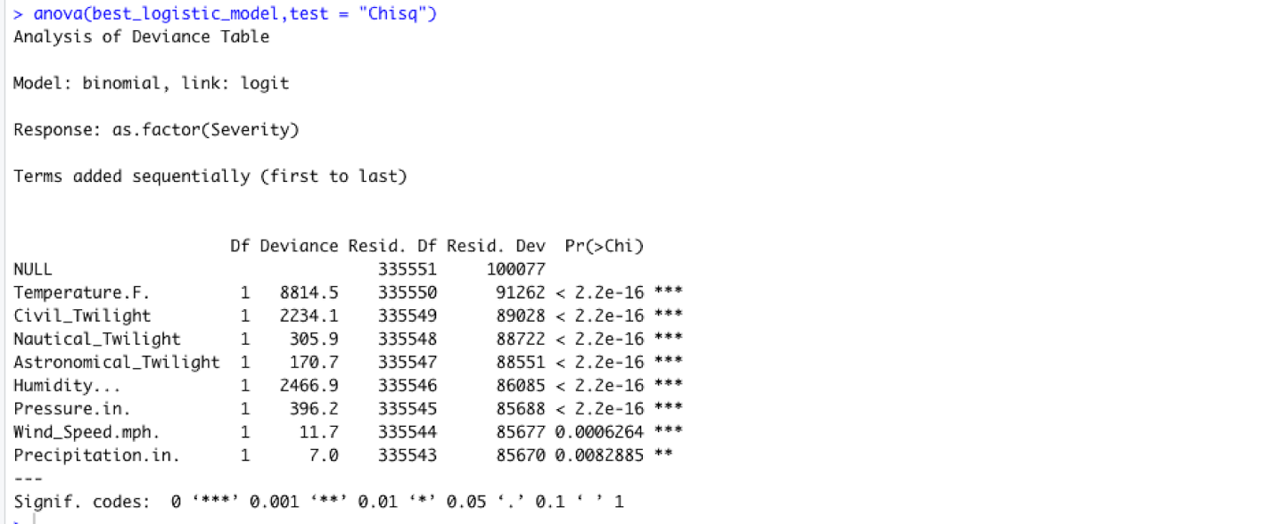

*Below map shows the cooks distance which interprets most effective independent variables for the dependent variable.

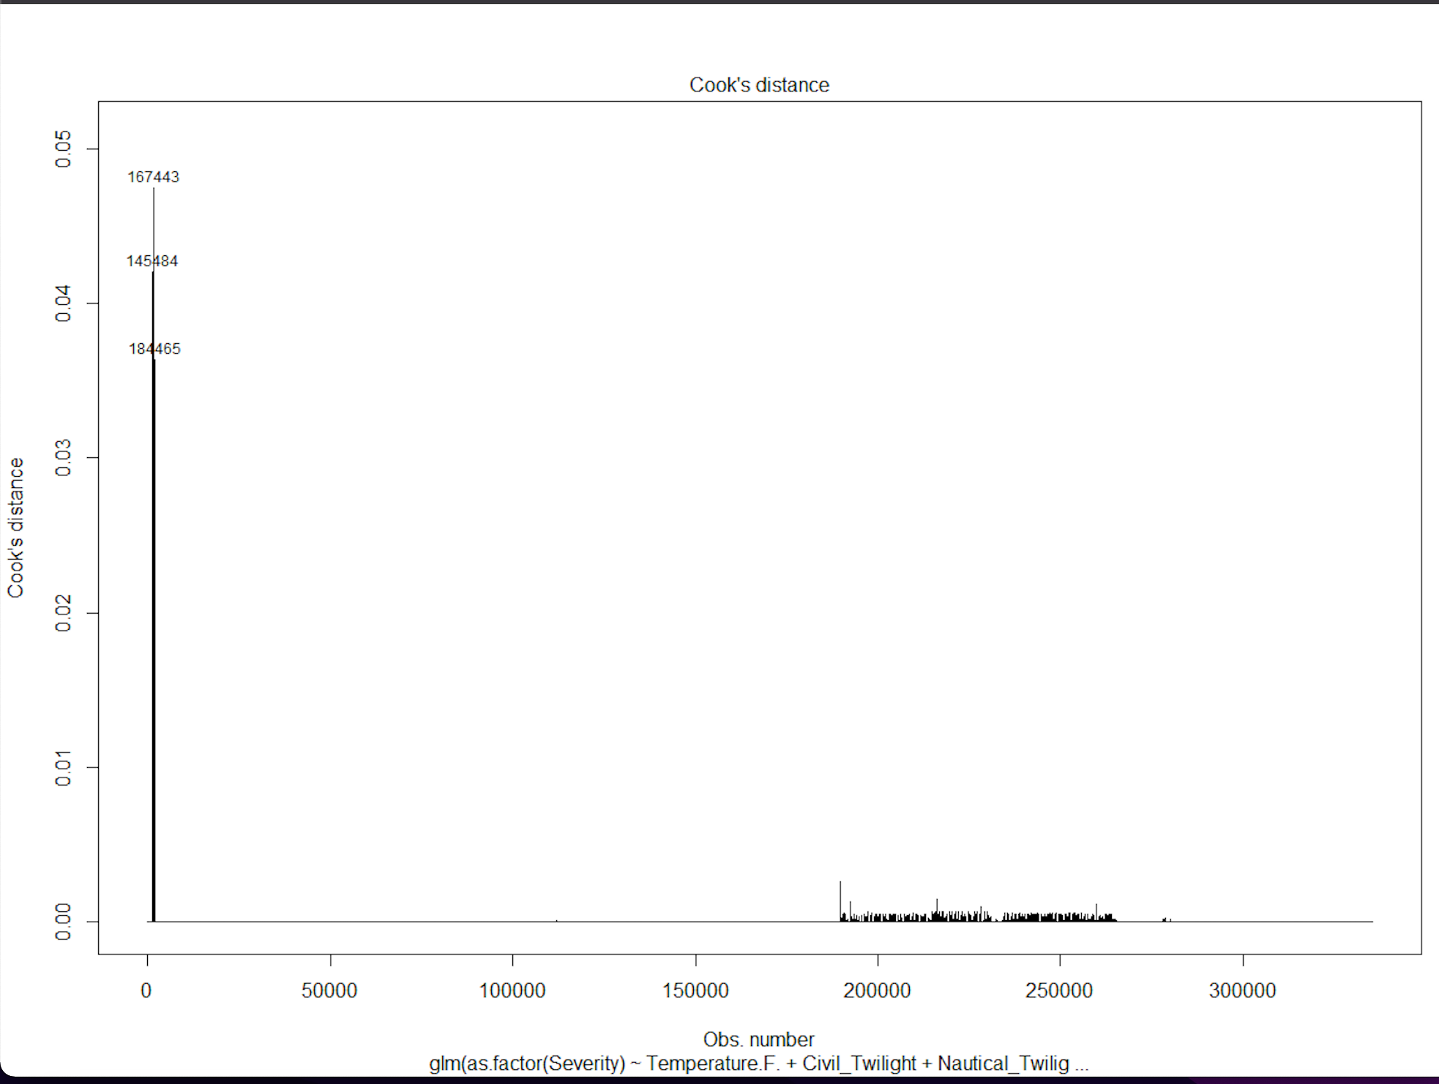

*Below plots show the assumption values for predicted and trained data.

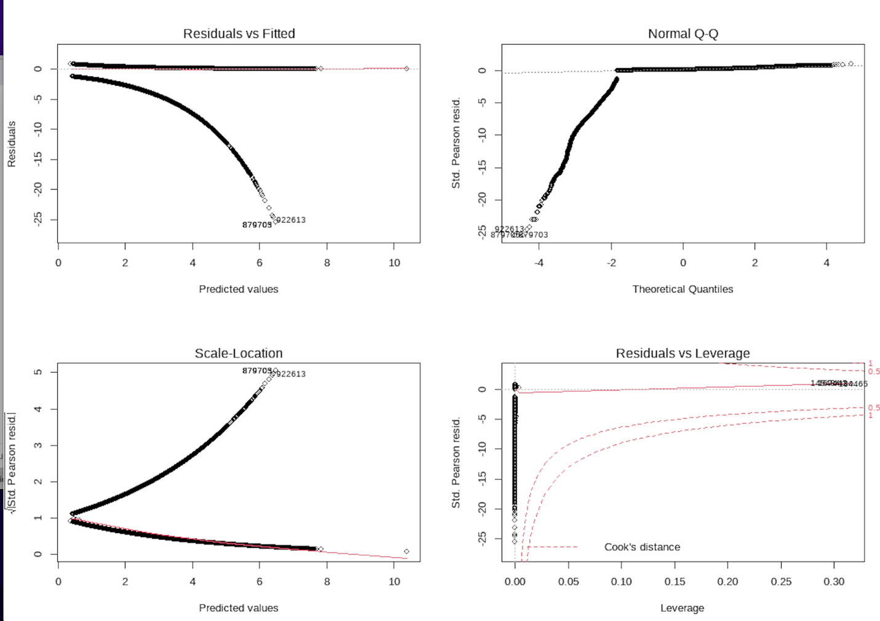

*VIF function shows the multicollinearity.



***Count of Severity:***

Count_severity = my_func(df, quo(Severity))

ggplot(data=Count_severity, aes(x=Severity, y=my_count)) +

geom_bar(stat="identity", fill="steelblue", width = 1)+

geom_text(aes(label=my_count), vjust=1.6, color="white", size=3.5)+

theme_minimal()

bp= ggplot(Count_severity, aes(x="", y=my_count,fill=Severity))+

geom_bar(width = 1, stat = "identity")

pie = bp + coord_polar("y", start=0)

pie

library(ggpubr)

ggboxplot(df, x = "Severity", y = "Wind_Chill.F.", width = 0.8)

Count_severity_city = my_func(df, quo(City))

Count_severity_city = head(Count_severity_city, 20)

ggplot(data=Count_severity_city, aes(x=City, y=my_count)) +

geom_bar(stat="identity", fill="steelblue", width = 1)+

geom_text(aes(label=my_count), vjust=2.6, color="white", size=2.5)+

theme_minimal()

**Findings:**

Number of accidents each hour:

Before Data cleaning:

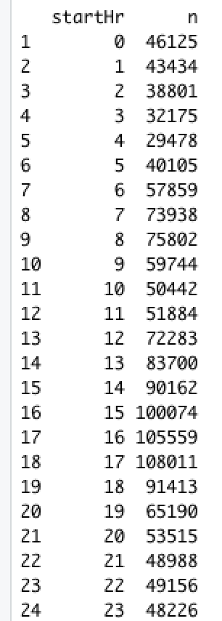 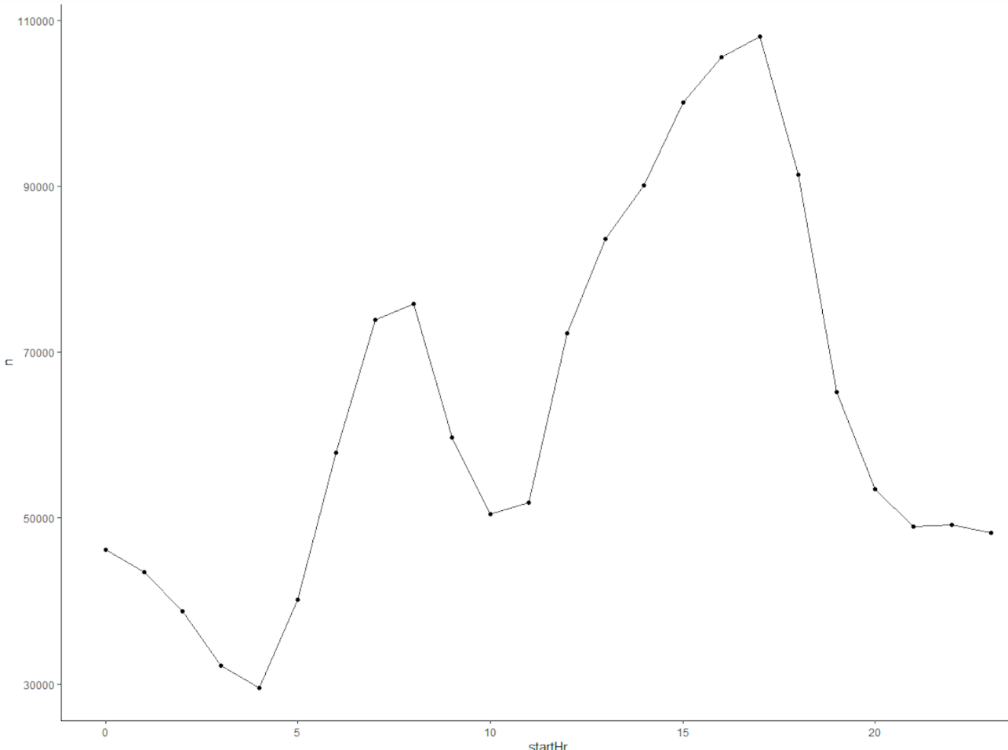

After Cleaning Data:

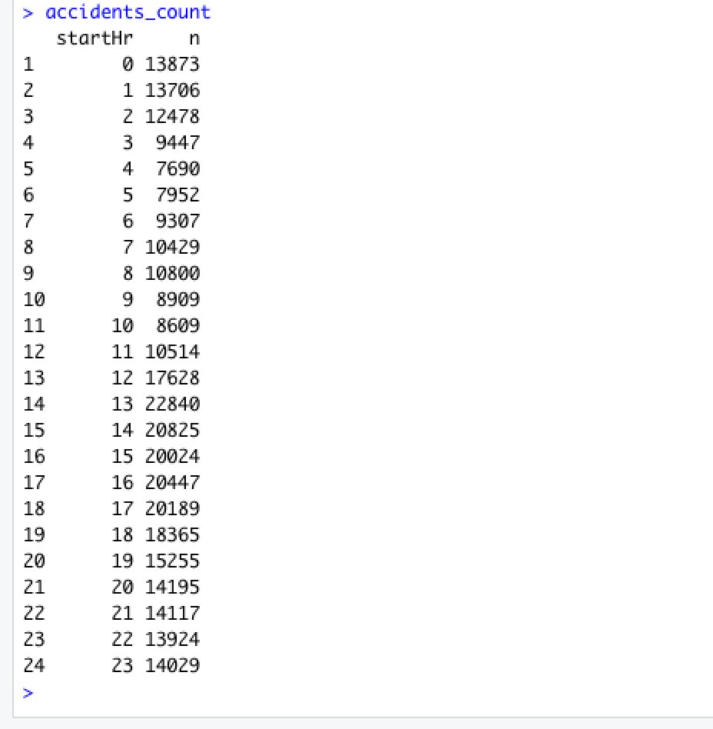 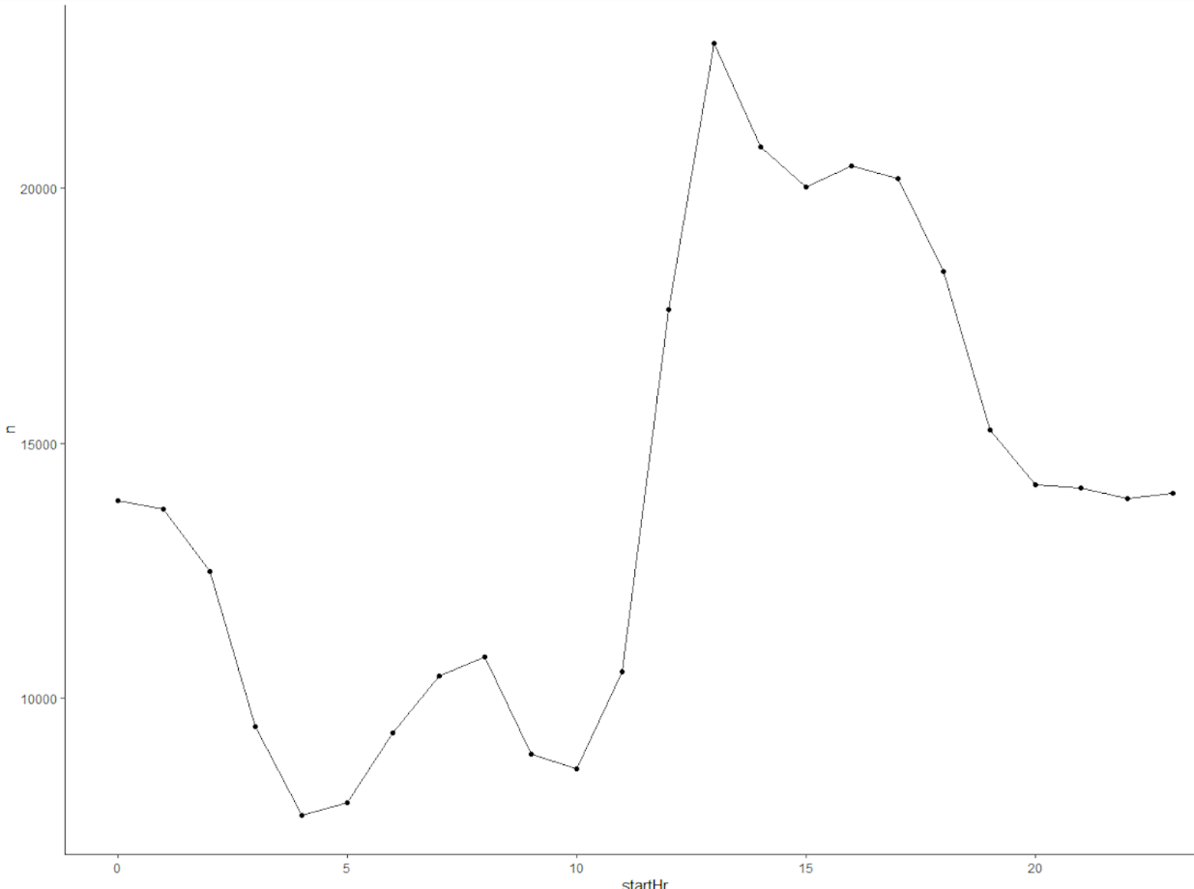

Accidents according to state:

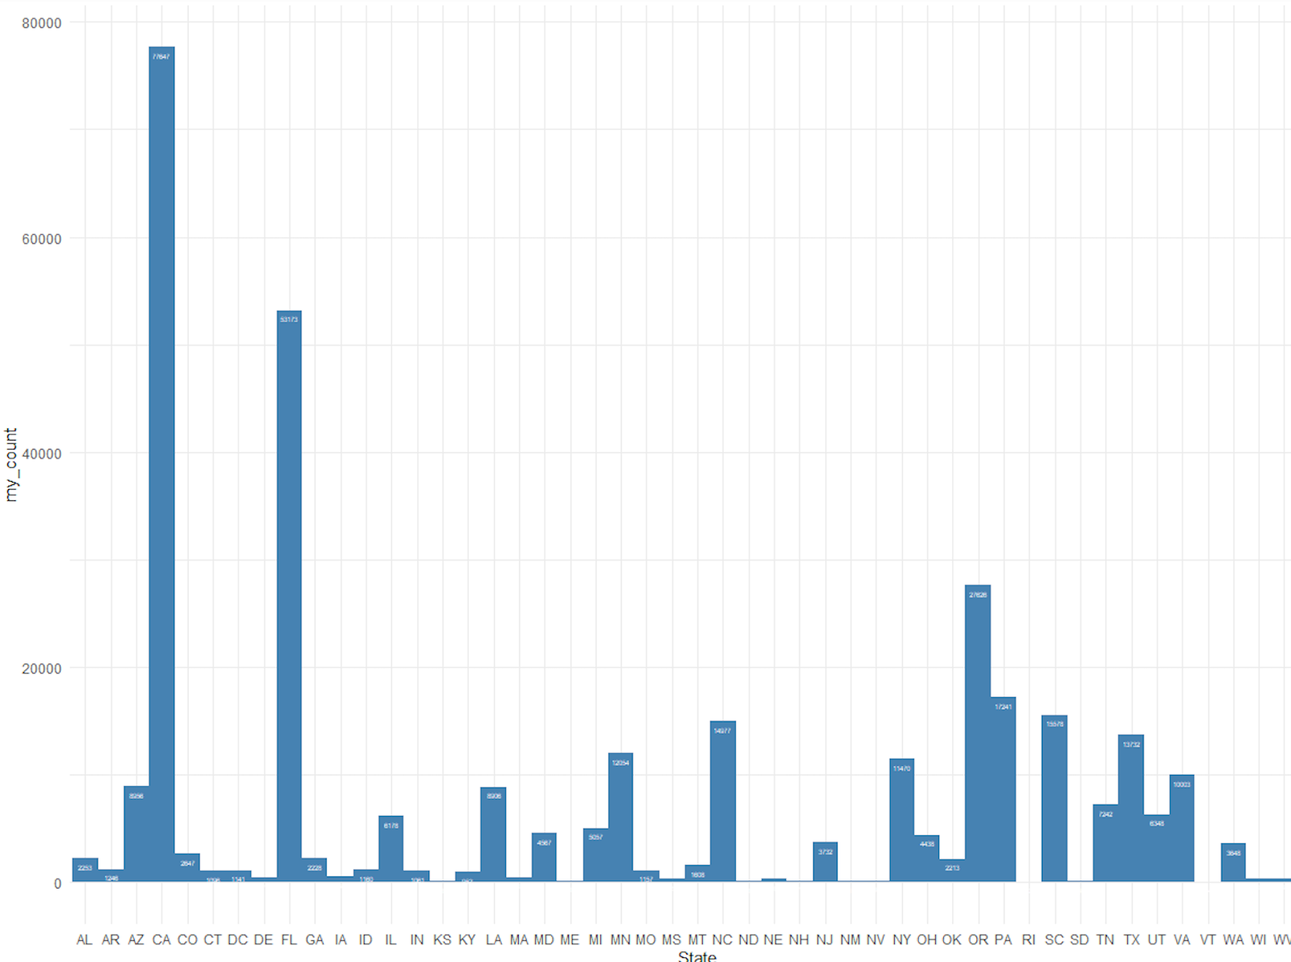

Severity:

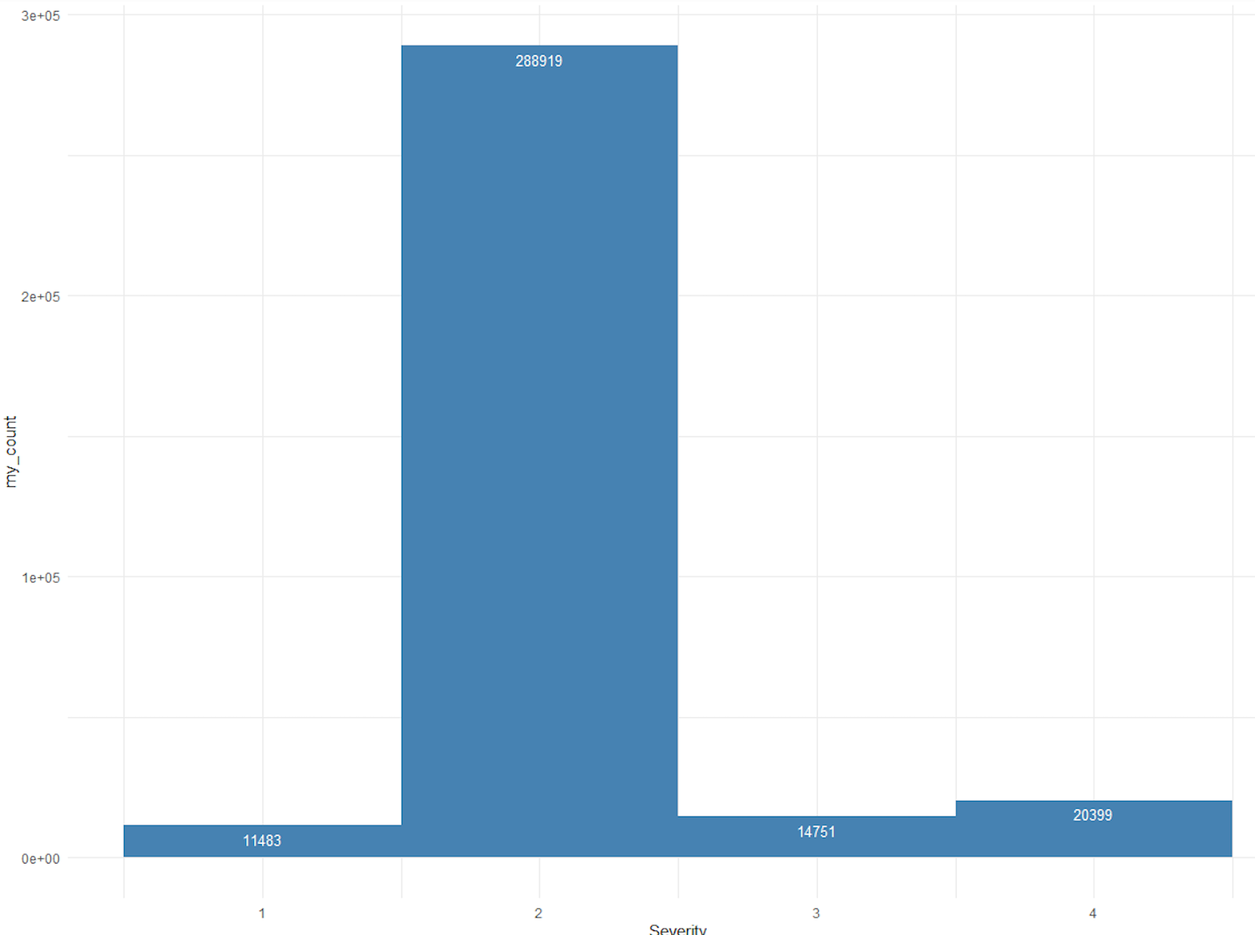

County:

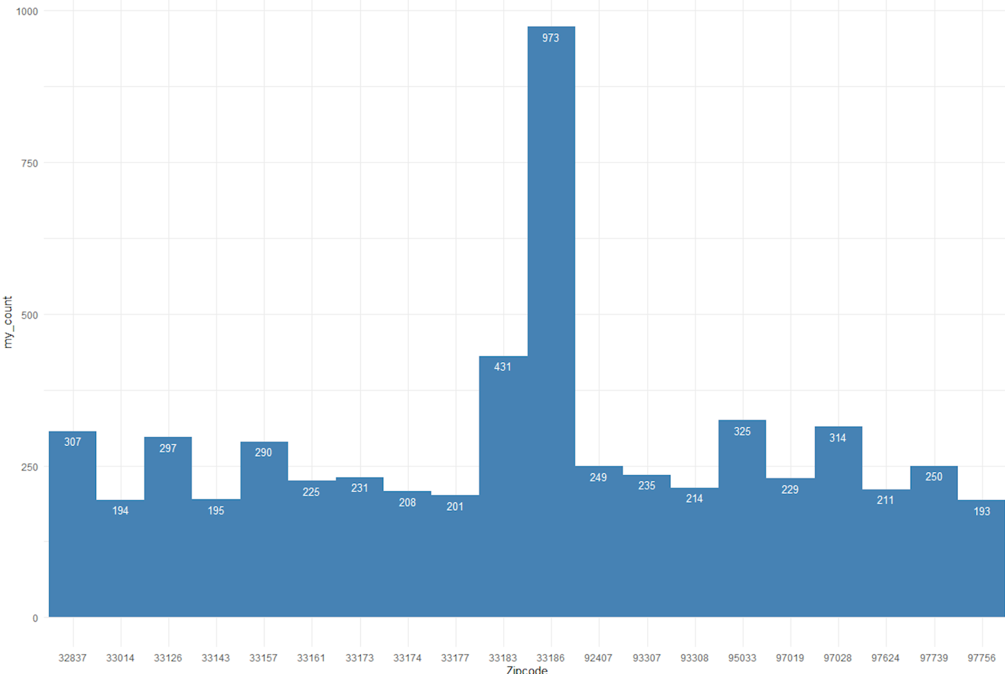

Streets:

